

The National Association of Women Judges
Presents

A Career on the Bench—the Plan and Possibilities

We ask ourselves: “who am I to be brilliant, gorgeous, talented and fabulous”? Actually, who are you not to be?

—Nelson Mandela, 1994
Johannesburg, South Africa

Welcome!
The National Association of Women Lawyers (NAWJ) offers you this opportunity to look into the future and see yourself as a judge presiding over your own courtroom in any state or U.S. territory (Puerto Rico, Guam, U.S Virgin Islands, and Northern Mariana Islands). This program gives you a glimpse into what it takes to become a judge, and the different judgeships waiting for you should you decide that a career in the law or judiciary is for you.

We are glad you are here, today.
We hope to someday see you on the Bench!

The National Association of Women Judges

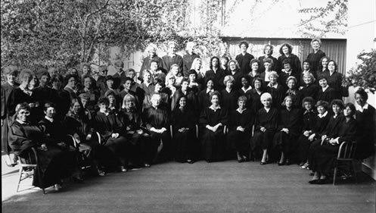

The National Association of Women Judges (NAWJ), Washington, DC seeks to ensure fairness and equality in the judiciary by increasing the ethnic and gender diversity of sitting judges in the U.S.. NAWJ has almost 1200 members--men and women, judges in appellate, trial, administrative, state and federal courts, and members from every state in the nation and from around the world.
http://www.nawj.org/
Co-Sponsors
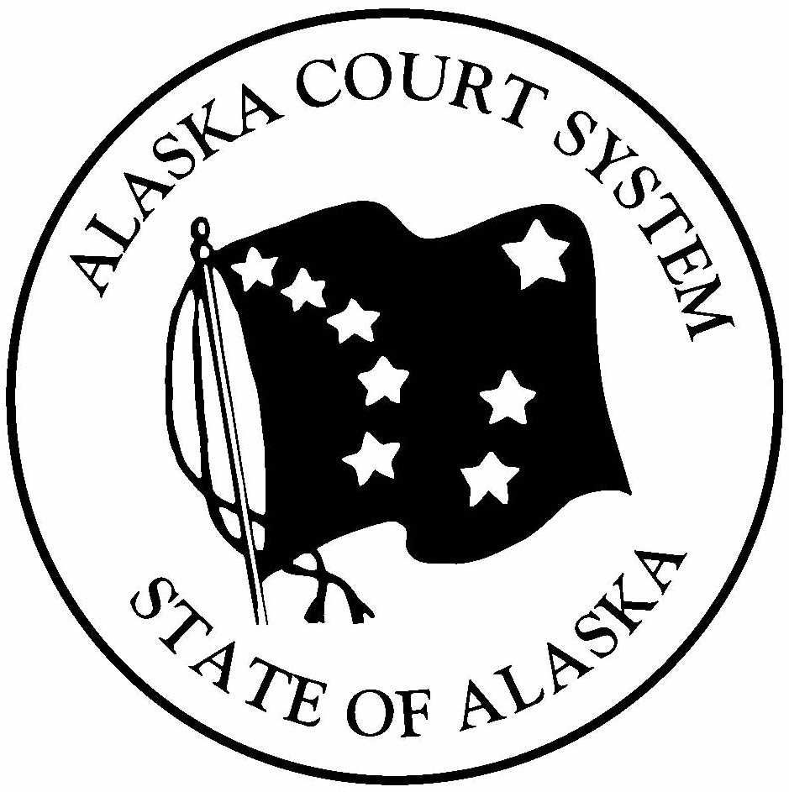





Alaska Court System
http://www.state.ak.us/courts/home.htm

University of Alaska Anchorage
http://www.uaa.alaska.edu/

The Alaska Native Justice Center
http://www.ciri.com/about_ciri/anjc.htm

Seattle University School of Law
http://www.law.seattleu.edu/

Gonzaga University School of Law
http://www.law.gonzaga.edu/

University of Washington School of Law
http://www.law.washington.edu/


The Bench
The Bar
The Three Branches of Government and the Courts
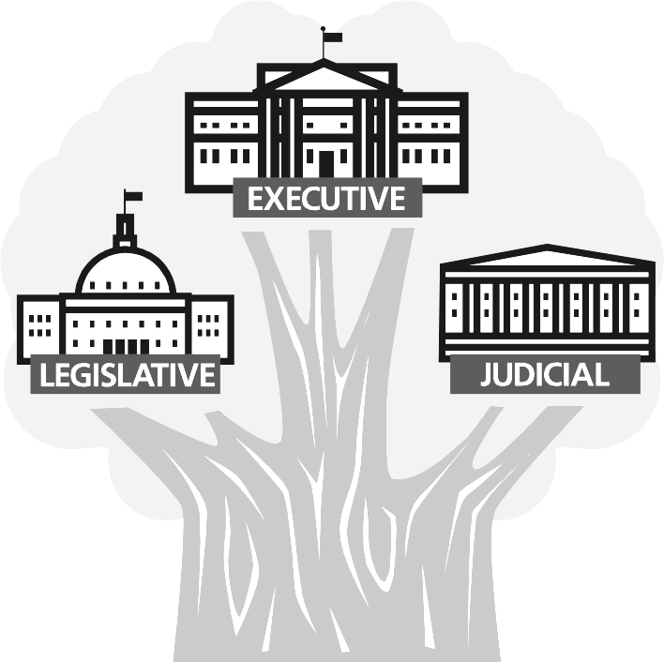
U.S. Constitution Article III. Section. 1. “The judicial Power of the United States shall be vested in one supreme Court
and in such inferior Courts as the Congress may from time to time ordain and establish”.
Other courts created by Congress within the Judicial Branch:
- U.S. Court of Appeals
  - U.S. District Courts (trial courts)
  - U.S. Bankruptcy Court
- U.S. Court of International Trade
- U.S. Court of Federal Claims

U.S. Code Title 5 Chapter 31 Subchapter I § 3105 Appointment of administrative law judges “Each agency shall appoint as many administrative law judges as are necessary for proceedings required to be conducted”.

A person suffering legal wrong because of any government agency action has the right to have his/her case reviewed by an Administrative Law Judge. There are 1,300 administrative law judges within the Executive Branch who conduct hearings, issue or recommend decisions, and enforce an agency’s regulations.

*Administrative Law judges are hired employees of a government agency, not judges who have been appointed or elected to the Bench.

U.S. Constitution Article I Section 8. “Congress shall constitute Tribunals inferior to the supreme Court”.

In addition to creating the U.S. Court of Appeals and lower courts within the Judicial Branch, Congress has created courts with specific legislative power:
- U.S. Court of Appeals for the Armed Services
- U.S. Court of Appeals for Veterans Claims
- U.S. Tax Court
- Administrative Law Judges (Administrative Procedures Act)

U.S. Constitution Article I Section 8. …To make Rules for the Government and Regulation of the land and naval Forces…to provide for organizing, arming, and disciplining, the Militia, and for governing such Part of them as may be employed in the Service of the United States
- Military Courts or Courts-Martial

States’ Courts
U.S. Constitution, Amendment X - The powers not delegated to the United States by the Constitution, nor prohibited by it to the states, are reserved to the states respectively, or to the people.

Each state has the power to create its own judiciary.
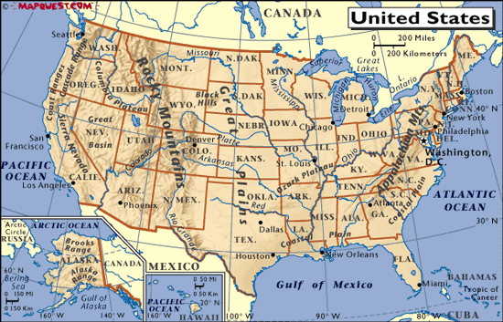
How does someone become a Judge?

Federal Bench
Federal judges are appointed to the Bench by the U.S. President and are confirmed by the U.S. Senate. They serve for life, and can only be removed for misconduct such as committing a crime or refusing to follow an order from a higher court.

State Bench
In some states judges are appointed by the governor, and they serve for a period of time stated in the state’s constitution. In some states, after sitting on the bench for several years, judges have to run for “retention” during an election. The voters get to decide whether the judges stay on the bench or not.

In other states judges run for office and are elected during a local election and have to run each time there is a general election.


Just think…
There are thousands of federal, state, district, municipal, and county courts in the U.S., and you could be a judge in any one of them…




The Federal Bench…

The Federal Bench within the Judicial Branch
U.S. Constitution Article. III. Section. 1. “The judicial Power of the United States shall be vested in one supreme Court
and in such inferior Courts as the Congress may from time to time ordain and establish”.
Other courts created by Congress within the Judicial Branch:
- U.S. Court of Appeals
  - U.S. District Courts (trial courts)
  - U.S. Bankruptcy Court
- U.S. Court of International Trade
- U.S. Court of Federal Claims

1st Circuit
Court of Appeals
Maine Bankruptcy Court
Maine District Court
Massachusetts Bankruptcy Court
Massachusetts District Court
New Hampshire Bankruptcy Court
New Hampshire District Court
Puerto Rico Bankruptcy Court
Puerto Rico District Court

Rhode Island Bankruptcy Court
Rhode Island District Court

2nd Circuit
Connecticut Bankruptcy Court
Connecticut District Court
Court of Appeals
New York Eastern Bankruptcy Court
New York Eastern District Court
New York Northern Bankruptcy Court
New York Northern District Court
New York Southern Bankruptcy Court
New York Southern District Court
New York Western Bankruptcy Court
New York Western District Court
Vermont Bankruptcy Court
Vermont District Court

3rd Circuit
Court of Appeals
Delaware Bankruptcy Court
Delaware District Court
New Jersey Bankruptcy Court
New Jersey District Court
Pennsylvania Eastern Bankruptcy Court
Pennsylvania Eastern District Court
Pennsylvania Middle Bankruptcy Court
Pennsylvania Middle District Court
Pennsylvania Western Bankruptcy Ct
Pennsylvania Western District Court
Virgin Islands District Court

4th Circuit
Court of Appeals
Maryland Bankruptcy Court
Maryland District Court
North Carolina Eastern Bankruptcy Ct
North Carolina Eastern District Court
North Carolina Middle Bankruptcy Ct
North Carolina Middle District Court
North Carolina Western Bankruptcy Ct
North Carolina Western District Court
South Carolina Bankruptcy Court
South Carolina District Court
Virginia Eastern Bankruptcy Court
Virginia Eastern District Court
Virginia Western Bankruptcy Court
Virginia Western District Court
West Virginia Northern Bankruptcy Ct
West Virginia Northern District Court
West Virginia Southern Bankruptcy Ct
West Virginia Southern District Court

5th Circuit
Court of Appeals
Louisiana Eastern Bankruptcy Court
Louisiana Eastern District Court
Louisiana Middle Bankruptcy Court
Louisiana Middle District Court
Louisiana Western Bankruptcy Court
Louisiana Western District Court
Mississippi Northern Bankruptcy Court
Mississippi Northern District Court
Mississippi Southern Bankruptcy Court
Mississippi Southern District Court
Texas Eastern Bankruptcy
Texas Eastern District Court
Texas Northern Bankruptcy Court
Texas Northern District Court
Texas Southern District/Bankruptcy Cts
Texas Western Bankruptcy Court
Texas Western District Court

6th Circuit
Court of Appeals
Kentucky Eastern Bankruptcy Court
Kentucky Eastern District Court
Kentucky Western Bankruptcy Court
Kentucky Western District Court
Michigan Eastern Bankruptcy Court
Michigan Eastern District
Michigan Western Bankruptcy Court
Michigan Western District Court
Ohio Northern Bankruptcy Court
Ohio Northern District Court
Ohio Southern Bankruptcy Court
Ohio Southern District Court
Tennessee Eastern Bankruptcy Court
Tennessee Eastern District Court
Tennessee Middle Bankruptcy Court
Tennessee Middle District Court
Tennessee Western Bankruptcy Court
Tennessee Western District Court
7th Circuit
Court of Appeals
Illinois Central Bankruptcy Court
Illinois Central District Court
Illinois Northern Bankruptcy Court
Illinois Northern District Court
Illinois Southern Bankruptcy Court
Illinois Southern District Court
Indiana Northern Bankruptcy Court
Indiana Northern District Court
Indiana Southern Bankruptcy Court
Indiana Southern District Court
Wisconsin Eastern Bankruptcy Court
Wisconsin Eastern District Court
Wisconsin Western Bankruptcy
Wisconsin Western District Court

8th Circuit
Arkansas Eastern District Court
Arkansas Eastern and Western Bankruptcy t
Arkansas Western District Court
Court of Appeals
Iowa Northern Bankruptcy Court
Iowa Northern District Court
Iowa Southern Bankruptcy Court
Iowa Southern District Court
Minnesota Bankruptcy Court
Minnesota District Court
Missouri Eastern Bankruptcy Court
Missouri Eastern District Court
Missouri Western District and Bankruptcy
Nebraska Bankruptcy Court
Nebraska District Court
North Dakota Bankruptcy Court
North Dakota District Court
South Dakota Bankruptcy Court
South Dakota District Court

9th Circuit
Alaska Bankruptcy Court
Alaska District Court
Arizona Bankruptcy Court
Arizona District Court
Bankruptcy Appellate Panel, 9th Circuit
California Central Bankruptcy Court
California Central District Court
California Eastern Bankruptcy Court
California Eastern District Court
California Northern Bankruptcy Court
California Northern District Court
California Southern Bankruptcy Court
California Southern District Court
Court of Appeals
Guam District Court
Hawaii Bankruptcy Court
Hawaii District Court
Idaho Bankruptcy/District Court
Montana Bankruptcy Court
Montana District Court
Nevada Bankruptcy Court
Nevada District Court
Northern Mariana Islands District Court
Oregon Bankruptcy Court
Oregon District Court
Washington Eastern Bankruptcy Court
Washington Eastern District Court
Washington Western Bankruptcy Court
Washington Western District Court

10th Circuit
Bankruptcy Appellate Panel, 10th Circuit
Colorado Bankruptcy Court
Colorado District Court
Colorado Federal Courts All Units
Court of Appeals
Kansas Bankruptcy Court
Kansas District Court
New Mexico Bankruptcy Court
New Mexico District Court
Oklahoma Eastern Bankruptcy Court
Oklahoma Eastern District Court
Oklahoma Northern Bankruptcy Court
Oklahoma Northern District Court
Oklahoma Western Bankruptcy Court
Oklahoma Western District Court
Utah Bankruptcy Court
Utah District Court
Wyoming Bankruptcy Court
Wyoming District Court

11th Circuit
Alabama Middle Bankruptcy Court
Alabama Middle District Court
Alabama Northern Bankruptcy Court
Alabama Northern District Court
Alabama Southern Bankruptcy Court
Alabama Southern District Court
Court of Appeals
Florida Middle Bankruptcy Court
Florida Middle District Court
Florida Northern Bankruptcy Court
Florida Northern District Court
Florida Southern Bankruptcy Court
Florida Southern District Court
Georgia Middle Bankruptcy Court
Georgia Middle District Court
Georgia Northern Bankruptcy Court
Georgia Northern District Court
Georgia Southern Bankruptcy Court
Georgia Southern District Court

DC Circuit
DC Bankruptcy Court
DC Circuit Court of Appeals
DC District Court

Federal Circuit
U.S. Court of Appeals for the Federal Circuit

The United States Supreme Court


The Highest Court of the land

You could be one of the 9 justices in the United States Supreme Court sitting in Washington, D.C.. Each year you and your fellow justices would hear a limited number of the cases that may have begun in the federal or state courts, and that involve important questions about the Constitution or federal law.
What changes occurred this past year in the Supreme Court?
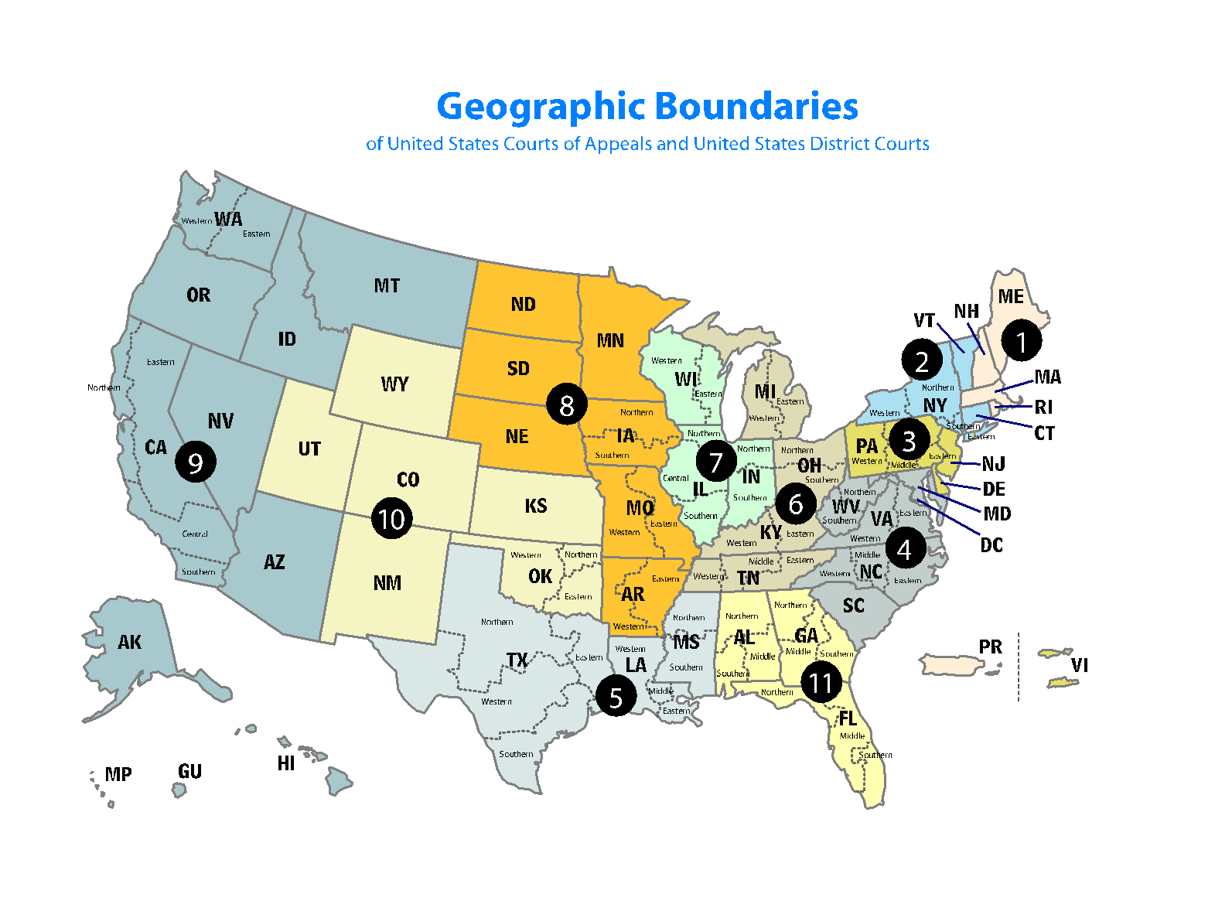
The U. S. Court of Appeals
You could sit on one of benches of the 12 regional circuits to hear appeals from the federal district courts below you.



The U. S. District Courts
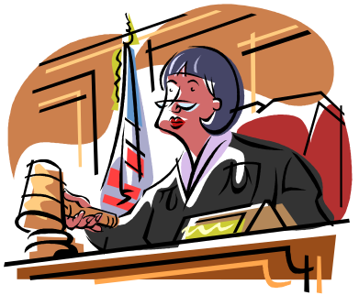
You could be a judge in one of the 94 federal judicial districts (these are trial courts) that send their appeals up to the Court of Appeals. At this level you may be living on the mainland or Guam, U.S. Virgin Islands, Northern Mariana Islands, or Puerto Rico!

The U.S. Bankruptcy Court
If you were one of the 94 judges on the U.S. Bankruptcy Court, you’d have exclusive jurisdiction over bankruptcy cases in which individuals, businesses and organizations that can’t pay their bills look to you for relief from creditors. Your role would be to protect the debtor’s and the creditor’s rights according to the federal bankruptcy laws which seek:
- to give an honest debtor a "fresh start" in life by relieving the debtor of most debts, and

- to repay creditors in an orderly manner to the extent that the debtor has property available for payment.



The U.S. Court of International Trade

If you are one of the 9 judges appointed to the U.S. Court of International Trade, you’d have jurisdiction over international trade throughout the United States. You’d hear cases that have to do with complex problems arising from international trade litigation. Since this court also is authorized to hold hearings in foreign countries, you might get to hear cases in some exotic locations!
Globe Metallurgical, Inc. v. United States
“Your Honor, we disagree with the U.S. Department of Commerce about how to determine the value of this shipment of steel we just brought from Russia.
Court No. 03- 00202


Gerber Food (Yunnan) Co. v. United States
“Your Honor, we are not dumping (selling below fair market price) this shipment of preserved mushrooms we just brought from the People’s Republic of China”. Court No. 03-00544


U.S. Court of Federal Claims
Your Honor, tell him! My contract bid was better than his!

This court has nationwide jurisdiction over money claims founded on federal statutes, executive regulations, government contracts, and the Constitution. If you were one of the 16 judges in the U.S. Court of Federal Claims you would hear cases involving:

- contract disputes and Constitutional claims
- actions for patent and copyright infringement
- tax refunds

- Indian claims
I invented it, Your Honor, not Watt!
- federal contract bid protests

- civilian and military pay claims
Your Honor, this is a tribal matter.
- vaccine injury claims
Your honor, I haven’t been paid since the Civil War!


Your Honor, I haven’t received my 1921 tax refund, yet!


Ouch! Your Honor, this flu shot made me very sick!

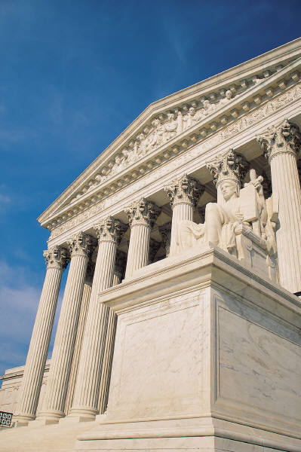
 A Federal Case
Attorneys practicing law in these areas at the federal level:
Alternative Dispute Resolution
Antitrust and Trade Regulation
Appellate Law
Bankruptcy Law
Corporate and Association Counsels
Criminal Law
Environment, Energy, and Natural Resources
Federal Career Service
Federal Litigation
Financial Institutions and the Economy
Government Contracts
Health Law
Immigration Law
Indian Law
Intellectual Property and Communications Law
International Law
Judiciary
Labor & Employment Law
Senior Lawyers
Social Security
State & Local Government Relations
Taxation
Transportation and Transportation Security Law
Veterans Law
  - Younger Lawyers

The Exxon Valdez

Business Editors/Environment Writers Jan. 28, 2004

ANCHORAGE, Alaska--David W. Oesting, lead plaintiffs' counsel for fishermen and natives in the Exxon Valdez oil spill litigation, confirmed today that Federal Judge Russell Holland has directed Exxon Mobil to pay $4.5 billion in punitive damages and approximately $2.25 billion in interest. The order stems from the civil lawsuit following the 1989 grounding of the Exxon Valdez and was entered in federal district court in Anchorage, Alaska this afternoon. The money is to go to 32,000 fishermen, natives, landowners, small businessmen and municipalities in south central Alaska whose lives and livelihoods were devastated by the spill.

Hundreds of lawsuits followed and were consolidated in front of Judge Holland. The cases were tried in 1994, and an Anchorage jury awarded $5 billion in punitive damages against Exxon Mobil on September 16, 1994. After initially contesting the award in front of Judge Holland, Exxon has since appealed the award three times. The case was before Judge Holland this last time to ensure that the amount of the award comported with constitutional limitations on punitive damage.

☺ A Federal District Court Judge

U.S. District Court Judge Denny Chin


ABOUT THE DENTAL FLOSS CASE

On Friday, January 7, 2005, U.S. District Judge Denny Chin ruled that Listerine mouthwash is not a replacement for dental floss -- despite confusing claims featured in advertising for Listerine mouthwash claiming that Listerine mouthwash was clinically proven to be as effective as floss in fighting plaque and gingivitis. The ruling was a result of a suit filed by McNeil-PPC, Inc., makers of Johnson & Johnson REACH(R) Dental Floss, who endorse the benefits of flossing as a foundation for good oral health.
In his written ruling, Judge Chin included this statement "Dentists and hygienists have been telling their patients for decades to floss daily," he wrote. "They have been doing so for good reason. The benefits of flossing are real."

As a federal judge in the Southern District of New York, Judge Chin sees some of the most cutting-edge cases in the country, so much so that three of his cases were used as plots for the popular Law and Order television series. But Chin's position is unique for another reason as well—he was the first Asian-American appointed to a federal district court judgeship outside the 9th Circuit, and is now just one of six Asian-American Article III judges today.

http://ceb.ucop.edu/newsletterv12/ListerineAd.htm

The Federal Bench created by U.S. Congress for specific legislative purposes

U.S. Constitution Article I Section 8. “Congress shall constitute Tribunals inferior to the supreme Court”.

In addition to creating the U.S. Court of Appeals and lower courts within the Judicial Branch, Congress has created courts with specific legislative power:
- U.S. Court of Appeals for the Armed Services
- U.S. Court of Appeals for Veterans Claims
- U.S. Tax Court
- Administrative Law Judges (Administrative Procedures Act)

U.S. Constitution Article I Section 8. …To make Rules for the Government and Regulation of the land and naval Forces…to provide for organizing, arming, and disciplining, the Militia, and for governing such Part of them as may be employed in the Service of the United States

- Military Courts or Courts-Martial

Military Courts or Courts-Martial
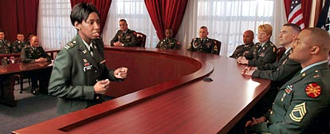
The Congressional Code of Military Criminal Law (UCMJ) applies to all U.S. military members worldwide, regardless of where they are stationed.

Courts-martial are judicial proceedings conducted by the U.S. military to uphold the UCMJ. Senior military commanders hold the power to prosecute, select judges, pick juries, and approve verdicts. Uniformed judges preside over the court. The hand-picked jurors, known as "members," are officers (and sometimes sergeants, if the accused is enlisted).

To serve as a military judge for a court-martial you’d have to be a Staff Judge Advocate (SJA) heading an office of the Judge Advocate General Corps (JAG). This would mean that you are a senior military and a member of the command staff. You’d have gotten to be an SJA by first working as an Assistant Staff Judge Advocate (military prosecutor) and area defense counsel (military defense attorney). As a military judge you would have authority to decide matters of law, to sentence soldiers to death for murder and for 14 other crimes, including espionage and aiding the enemy (during a war). Your court decisions could be appealed to the U.S. Court of Appeals for the Armed Forces and all the way to the U.S. Supreme Court.
U.S. Court of Appeals for the Armed Forces

Since military courts-martial have the power to hand down severe sentences including the death penalty to convicted military members, Congress created a civilian court that specifically ensures fairness and due process for military personnel--The U.S. Court of Appeals for the Armed Forces. This court also has worldwide appeals jurisdiction over members of the armed forces.


If appointed to this court you’d be one of five (5) civilian judges who would hear appeals of cases involving constitutional law, criminal law, evidence, criminal procedure, ethics, administrative law, and national security law. Your decisions in this court would be subject to direct review by the U.S. Supreme Court.

I thought there were only five of us judges…?

 A Court Martial

U.S. Army Sgt. Hasan Akbar – A Court Martial

Soldier Sentenced to Death for Iraq War Murder

Sergeant accused in grenade attack that killed two

(N.Y. Times, April 29, 2005 (AP))
A 15-member military jury sentenced Sgt. Hasan Akbar to death for killing 2 U.S. military officers in Kuwait in 2003 during the opening days of the Iraq invasion. At his sentencing, Akbar said, "I want to apologize for the attack that occurred. I felt that my life was in jeopardy, and I had no other options. I also want to ask you for forgiveness." He is the first American since the Vietnam era to be prosecuted for murdering a fellow soldier in wartime.

U. S. Court of Appeals for Veterans Claims

This federal court was created by Congress to review decisions made by the Board of Veterans Affairs about a veteran’s benefits. In spite of its name this Court is not part of the U.S. Department of Veterans Affairs (VA). It is located in Washington, D.C., and if you were one of its seven (7) judges appointed by the President you’d review files about a veteran’s entitlement to disability or survivor benefits, or the amount of those benefits, education benefits, life insurance, home loan foreclosure, or waiver of indebtedness.


U.S. Tax Court
STOP! He doesn’t have to pay his taxes until we say “he has to pay his taxes!”


Congress created this federal court to hear cases where a person is disputing his/her tax liabilities to the Internal Revenue (IRS). This court makes it possible for the affected person to hold off having to pay the tax liability while this court decides whether he has to pay it or not.


If you sat on this court you’d be one the 19 judges, or one of the senior judges serving on recall, or a special trial judge. You’d have to have expertise in the tax laws and be able to apply that expertise in a manner to ensure that taxpayers are assessed only what they owe, and no more.

Although the court is physically located in Washington, D.C., you’d travel nationwide to conduct trials in various designated cities.
Tribal Courts*

With the passage of the Indian Reorganization Act in 1934, Native American and Native Alaskan tribes were encouraged by the federal government to enact their own laws and to establish their own justice systems. Members of a federally-recognized Native American or Native Alaska village, tribe, or council could get together and form a tribal court and appoint a tribal judge. Since then, approximately 300 Indian nations and Alaska Native villages have established formal tribal court systems.

Tribal courts may have limited jurisdiction over their community or concurrent jurisdiction with a state or federal court. But for the most part they are independent for purposes of hearing and deciding divorces, custody and misdemeanors. These courts can be highly structured such as the Cherokee Nations Judicial Tribunals in Kansas, or as informal as some of the ones in Alaska which are run by dedicated volunteer elders or members of the tribal council.
*Tribal court judges have to be members of a federally-recognized Native American or Native Alaskan tribe or village.
☺ Tribal Court Judges
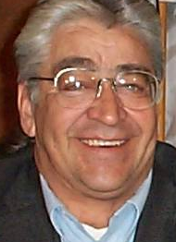
The Honorable David D. Raasch
Chief Judge, Stockbridge-Munsee Band of Mohicans Tribal Court, Bowler, Wisconsin.

Judge Raasch was sworn in to the bench in 1995. He is a former police officer, has taught and been a speaker at the UCLA School of Law, the Northeast Wisconsin Technical College, and the University of California Clark Kerr Campus. Recently, Judge Raasch worked in the development of tribal courts in Alaska, teaching for the Athabascan College, Tanana Chief’s Conference, the Alaska Inter Tribal Council, the Bristol Bay Native Association, and the National Judicial College. He is the President of the Wisconsin Tribal Judges’ Association and was the first Native American tribal judge to speak at the investiture ceremony of a federal district judge in Wisconsin. Judge Raasch was the Keynote Speaker at the Alaska Color of Justice 2005


The Honorable Stacy Leeds
Cherokee Nation’s Highest Court’s First Female Justice

Stacy Leeds joined the KU faculty in 2003 after serving as Assistant Professor and Director of the Northern Plains Indian Law Center at the University of North Dakota School of Law. Her law teaching career began at the University of Wisconsin School of Law where she received her LL.M. as a William H. Hastie Fellow. She received her bachelor's degree from Washington University in St. Louis and her law degree from the University of Tulsa.

In August 2002, she became the first woman confirmed to the highest court of the Cherokee Nation of Oklahoma, where she is currently serving a six year appointment. She is a highly regarded speaker and routinely presents at national conferences on a variety of legal issues affecting American Indian people.

Administrative Law Judges within the Executive Branch
U.S. Code Title 5 Chapter 31 Subchapter I § 3105 Appointment of administrative law judges “Each agency shall appoint as many administrative law judges as are necessary for proceedings required to be conducted”.

A person suffering legal wrong because of any government agency action has the right to have his/her case reviewed by an Administrative Law Judge. There are 1,300 administrative law judges within the Executive Branch who conduct hearings, issue or recommend decisions, and enforce an agency’s regulations.

*Administrative Law judges are hired employees of a government agency, not judges who have been appointed or elected to the Bench.

Administrative Law Judges
A special category of hearing officers

You could be an administrative law judge in one of the 61 Administrative Law Judges Offices (ALJO) that exist in the federal government agencies. That would mean that you are a practicing attorney hired by a government agency to hear complaints brought against that particular agency. While you would be called an Administrative Law Judge, you would not be a member of the Bench, but of the Bar. In some agencies you could only make recommendations about a case; in others you could render final decisions.

For example:
- OSHA
The Occupational Safety and Health Review Commission is an independent federal agency created to decide contests of citations or penalties resulting from OSHA inspections of American work places. Their administrative law judges conduct hearings and render final decisions.
- EPA
The U.S. Environmental Protection Agency's Office of Administrative Law Judges (OALJ) is an independent office in the Office of the Administrator of the EPA. The Administrative Law Judges conduct hearings and render decisions in proceedings between the EPA and persons, businesses, government entities, and other organizations which are or are alleged to be regulated under environmental laws.
☺A Federal Administrative Law Judge

Judge Carmen A. Cintron
Federal Energy Regulatory Commission (FERC)
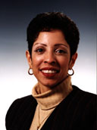

Judge Carmen A. Cintron is an administrative law that works to resolve contested cases as directed by the FERC through impartial hearing and decision or through negotiated settlement.
Judge Cintron obtained a bachelor's degree in business administration, magna cum laude and a J.D. cum laude, both from the University of Puerto Rico. She was the recipient of the Resumil Award, which is given to the graduate achieving the highest average in criminal law.
While in law school, she was an intern in the U.S. Attorney's office in San Juan, Puerto Rico. She also worked in the Clerk's office in the U.S. Federal District Court for Puerto Rico implementing the Speedy Trial Act for both the Puerto Rico and Saint Thomas, Virgin Islands Federal District Courts




The State Bench…
The State of Alaska Court System
- You could be one of the five (5) Justices of the Alaska Supreme Court hearing oral arguments and writing opinions about cases that involve Alaska law.
- You could be one of these three (3) judges in the Alaska Court of Appeals hearing appeals from lower courts throughout Alaska.
- You could be one of 34 superior court judges in the Superior Court Districts presiding over criminal and civil trials.
- You could be one of the 17 district court judges who have jurisdiction over misdemeanors, only.
- Or you could be a magistrate (Magistrates are not judges, but in many outlying areas in Alaska they fulfill the role of a judge). To be a magistrate you’d be appointed by the presiding judge to do some of the things he or she does in his/her district. You’d hear misdemeanors, conduct marriage ceremonies, do arraignments, etc.

Therapeutic Courts in Alaska and other States


You could be one of thousands of judges that preside over therapeutic courts in the U.S. The common elements in these courts are; a court team that monitors the participant while he/she undergoes treatment, drug and alcohol testing, regular reporting directly to a judge, and engaging in services that assist the participant to become self-supporting. The court team responds immediately to the participant’s success and relapse, and maintains direct involvement with the participant in court for a longer period of time than required for conventional criminal proceedings. Depending on the court, the participants can be adult felons, misdemeanants, juveniles, parents involved in child protection cases, and persons charged with crimes of domestic violence. There are almost 1500 therapeutic courts in the nation. Alaska has these therapeutic courts: Mental Health Court, Wellness Court, Felony Drug Court, Felony DUI Court, Family Court

How do you get to be a judge in Alaska?
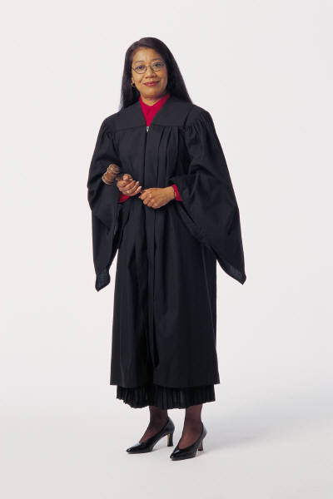
You have to be a licensed attorney admitted into the Alaska Bar Association. After you practice law for a several years you submit your name to the Alaska Judicial Council (AJC). The AJC reviews your background and credentials, and based on these and on an opinion poll of all the Bar members, decides whether or not to include your name among the list of three names it sends to the Governor. After receiving the list the Governor has 45 days to decide who to appoint. He could appoint YOU!

At the first general election held more than 3 years after you’ve been appointed, you must stand for retention and are subject to approval or rejection by a majority of voters statewide on a nonpartisan ballot. The voters in the state decide if you stay or not on the bench…

☺ A Justice of a State Supreme Court

Justice Petra Jimenez Maes
Justice of the New Mexico Supreme Court

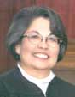
Justice Jimenez Maes was born in Albuquerque, New Mexico in 1947, and in 1998 she became the first Hispanic woman to serve on a state supreme court. She was one of the first two Hispanic Women to graduate from UNM Law School in 1978. After the death of the husband in 1983, Justice Jimenez Maes raised her four children as a single parent. Her children are now ages 20 to 27.

Picture Yourself on the Bench!


The Job: You are expected to protect justice and the legal rights of those who appear in your courtroom.
The Salary: According to Salary.com the base salary for a judge or magistrate is: $119,080 a year, average salary is $121,399 a year, and judges in the 75th percentile receive on average $135,859 a year. On average each month a judge in the United States receives $7,024 in social security, $2,962 in disability, $5,390 in healthcare, a pension of $3,933, and time off benefits of $13,261.

The Required Background: Most of the states in the U.S. require that you have earned a J.D. that includes four years of undergraduate study and three years of law school, followed by up to five years of legal experience in private practice or in public practice such as public defender, district attorney or attorney general. The more varied and substantial your experience, coupled with a good reputation for fairness, decency and professionalism, the better your chances!
Plan for it!
It all starts with college and then law school!







In the U.S. there are200

law schools from which to choose

The most important question you’ll be asked when you apply to law school is “Why do you want to attend law school”? “Why do you want to go to law school, instead of to med school, air traffic control school, chef school?”

According to law school admissions directors, very few applicants answer the question in a manner than gets them admitted.

University of Akron Law School
- University of Alabama Law School
- Albany Law School of Union University
- American College of Law
- American University
- Appalachian School of Law
- University of Arizona, Tucson
- Arizona State University
- University of Arkansas, Fayetteville
- University of Arkansas, Little Rock
- University of Baltimore
- Baylor University
- Birmingham School of Law
- Boston College
- Boston University
- Brigham Young University
- Brooklyn Law School
- California Pacific School of Law
- California Western
- University of California, Berkeley
- University of California, Davis
- University of California, Hastings
- University of California, Los Angeles
- Campbell University
- Benjamin N. Cardozo School of Law (Yeshiva University)
- Capital University
- Case Western Reserve University
- Catholic University Of America
- University of Chicago
- Chicago-Kent College of Law
- University of Cincinnati
- Cleveland State University
- University of Colorado
- Columbia University
- University of Connecticut
- Cornell University
- Creighton University
- University of Dayton
- University of Denver
- DePaul University
- University of Detroit
- Detroit College of Law
- Dickinson School of Law
- District of Columbia School of Law
- Drake University
- Duke University
- Duquesne University
- Emory University
- University of Florida
- Florida State University
- Fordham Law School
- Franklin Pierce Law Center
- George Mason University
- George Washington University
- Georgetown University
- University of Georgia
- Georgia State University
- Glendale University College of Law
- Golden Gate University
- Gonzaga University
- Hamline University
- Harvard University
- Hawaii (University of)
- Hastings College of the Law (UC)
- Hofstra University
- University of Houston
- Howard University
- University of Idaho
- University of Illinois
- Indiana University, Bloomington
- Indiana University, Indianapolis
- University of Iowa
- John F. Kennedy University
- The John Marshall Law School
- University of Kansas
- University of Kentucky
- Lewis and Clark College: Northwestern School of Law
- Lincoln Law School of Sacramento
- Louisiana State University
- University of Louisville
- Loyola Marymount University
- Loyola University, Chicago
- Loyola University, New Orleans
- University of Maine
- Marquette University
- Marshall-Whythe School of Law (College of William and Mary)
- Thurgood Marshall School of Law (Texas Southern)
- University of Maryland
- Massachusetts School of Law
- McGeorge School of Law (Univ. of the Pacific)
- University of Memphis
- Mercer University
- University of Miami, Florida
- University of Michigan, Ann Arbor
- University Of Minnesota
- Mississippi College School of Law
- University of Mississippi
- University of Missouri, Columbia
- University of Missouri, Kansas City
- University of Montana
- University of Nebraska
- University of Nevada, Las Vegas
- New College of California School of Law
- New England School of Law
- University of New Mexico
- City University of New York
- State University of New York
- New York Law School
- New York University
- University of North Carolina
- North Carolina Central University
- University of North Dakota
- Northeastern University
- Northern Illinois University
- Northern Kentucky University
- Northwestern University
- Notre Dame
- Nova Southeastern University
- Ohio Northern University
- Ohio State University
- University of Oklahoma
- Oklahoma City University
- University of Oregon
- University of Orlando School of Law
- Pace University
- University of the Pacific
- University of Pennsylvania
- Peoples College of Law
- Pepperdine University
- University of Pittsburgh
- Quinnipiac College
- Regent University School of Law
- University of Richmond
- Roger Williams School of Law
- Rutgers University, Camden
- Rutgers University, Newark
- St. John's University, New York
- St. Louis University
- Samford University
- University of San Diego
- University of San Francisco
- San Francisco Law School
- Santa Clara University
- Saratoga University Law School
- Seattle University Law School
- Seton Hall University
- University of South Carolina
- University of South Dakota
- South Texas College of Law
- University of Southern California
- Southern Illinois University
- Southern Methodist University
- Southern New England School of Law
- Southwestern University
- Stanford University
- Stetson University
- St.Thomas University School of Law
- Suffolk University
- Syracuse University
- Temple University
- University of Tennessee
- University of Texas
- Texas Southern University
- Texas Tech University
- Texas Wesleyan University School of Law
- Thomas M. Cooley Law School
- Thomas Jefferson School of Law
- University of Toledo
- Touro College
- Trinity Law School
- Tulane University
- University of Tulsa
- University of Utah
- Valparaiso University
- Vanderbilt University
- Vermont Law School
- Villanova University
- University of Virginia
- Wake Forest University
- Washburn University
- University of Washington
- Washington and Lee University
- Washington University
- Wayne State University
- West Virginia University
- Western New England College
- Western State University College of Law
- Whittier College
- Widener University
- Willamette University
- College of William and Mary
- William Mitchell College of Law
- University of Wisconsin
- University of Wyoming
- Yale University
- Yeshiva University


the plan…

- High School - Take courses in government, writing, debate and public speaking
- Undergraduate college degree - Get your undergraduate degree in an area you really enjoy. Take courses in logic, writing, debate, and public speaking.
- Take the LSAT – Take the Law School Admissions Test. Apply, attend, and succeed at law school.
- Law degree - Get your Juris Doctor (J.D.) degree from a law school accredited by the American Bar Association.
- Bar Exam - Take and pass the bar exam of the state in which you want to work.
- Experience - Get solid legal experience in various areas of the law.
- Build Skills –Get good at impartial analytical thinking, writing, and speaking. Perfect your listening, sumarizing, and decision-making skills. Stay current on laws, on cases that have set precedents, court rules and subjects involving your cases. Get involved in your community in a positive, helpful manner.
- Throw your hat in the ring -Submit your name for a judgeship when there is vacancy.
- Call, write or email us and let us know that you’ve become a judge!
the possibilities…



To gain legal experience before you apply to sit on the Bench you practice, practice, practice law…
White House Counsel
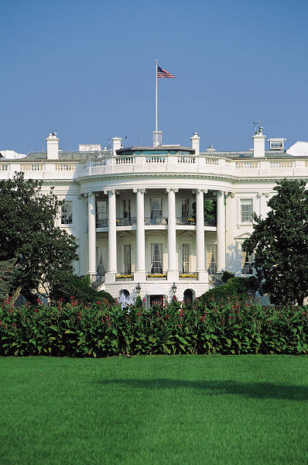
You could be appointed by the President to be The White House Counsel. Your role would be to advise the President on all legal issues concerning the President and the White House.


You’d work in the Office of Counsel to the President which is responsible for advising on all legal aspects of policy questions, legal issues arising in connection with the President's decision to sign or veto legislation, ethical questions, financial disclosures, and conflicts of interest during employment and post employment. The Counsel's Office also helps define the line between official and political activities, oversees executive appointments and judicial selection, handles Presidential pardons, reviews legislation and Presidential statements, and handles lawsuits against the President in his role as President, as well as serving as the White House contact for the Department of Justice.

Although as White House Counsel you’d offer legal advice to the President, you would do so in the President's official capacity, and not as the President's personal attorney. The President relies on a personal attorney for personal confidential legal advice.
Federal Assistant U.S. Attorney General
In the U.S. Department of Justice, the “law firm of the federal government”.

You could be one of 93 U. S. Attorneys General who are stationed throughout the 50 states, Puerto Rico, the U.S. Virgin Islands, Guam, and the Northern Mariana Islands.

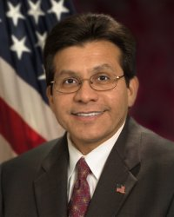
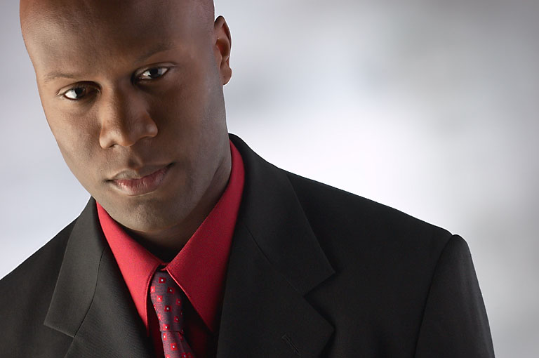

As a U.S. Assistant Attorney General in the civil division, you’d work under the U.S. Attorney General and in the name of the United States to defend and prosecute civil litigation to which the U.S. is a party; give advice to the president; review federal regulations, and draft and review legislation.

As a Federal Prosecutor in the criminal division, you’d also work under the U.S. Attorney General and in the name of the United States to prosecute and seek to convict criminal offenders in urban and rural areas who violate federal laws.

You could be the U.S. Attorney General, the head of the U.S. Department of Justice, just like The U.S. Attorney General Alberto R. Gonzalez who was sworn in as the nation's 80th Attorney General in 2005.
State Assistant Attorney General
For the Alaska Department of Law, the “law firm of the state”

You could be an Assistant Attorney General (AG) and work under a State Attorney General. In the name of the State you would defend and prosecute civil litigation to which the state is a party; give advice to the governor; review regulations, and draft and review legislation.

You could be an Assistant District Attorney (DA) and also work under the State Attorney General. In the name of the State you would prosecute and seek to convict criminal offenders in urban and rural areas.

Or you could be The State’s Attorney General, just like Alaska’s Attorney General, David W. Márquez
Judge Advocate General in Courts Martial
In the JAG Corps, the “law firm of the U.S. military

To be a judge advocate (JAG) in the U.S. Army, U.S. Navy, or U.S. Air Force, you have to be a law school graduate who has passed a bar exam in at least one state, and must have a military rank of first lieutenant or above.
- Assistant Staff Judge Advocate The Judge advocate that handles claims, international law issues, military justice issues, civil and administrative law, and serves as a prosecutor at military trials.
WARNING! Professional actors in a movie set. Don’t try this at home.
- Area Defense Counsel The Judge advocate who represents military members suspected of committing military crimes.


Name this film…
Jessep (Jack Nicholson): You want answers!?
Kaffee (Tom Cruise): I think I'm entitled to them!!
Jessep: You want answers!!?
Kaffee: I want the truth!
Jessep: You can't handle the truth! …I did the job you sent me to do.
Kaffee: Did you order a code red!!!?
Jessep: You're &8%#!8 right I did!!

Law Revision Counsel in Congress

If you work in the Office of the Law Revision Counsel of the U.S. House of Representatives you’d prepare and publish the United States Civil Code, a consolidation and codification by subject matter of the general and permanent laws of the United States.



☺ An Example of Law Revision
2004 Amendments to the Commercial Space Act of 1998

Private-spaceflight bill signed into law
After long struggle, law opens way for space tourism
Fly me to the moon!

By Alan Boyle
Science editor, MSNBC
Updated: 6:21 p.m. ET Dec. 23, 2004



WASHINGTON - President Bush gave suborbital space companies an early Christmas gift on Thursday by signing a bill that helps open the way for commercial tourism on the final frontier.

The Commercial Space Launch Amendments Act, or H.R. 5382, puts a clear legislative stamp on regulations already being formulated by the Federal Aviation Administration. More significantly, the law would eventually let paying passengers fly on suborbital launch vehicles at their own risk.
The age of commercial space travel got its start this summer with SpaceShipOne's first private-sector spaceflights. Since then, hundreds of would-be tourists, including William Shatner of "Star Trek" fame and "Alien" actress Sigourney Weaver, have voiced interest in taking their own suborbital space trips aboard the successors to SpaceShipOne, which may be ready for flight in 2007 or 2008.

The backers of H.R. 5382 said the legislation was needed to reassure potential investors, such as Virgin Group billionaire Richard Branson, that they would not face crippling lawsuits in an inherently risky business.

The bill's sponsor, Rep. Dana Rohrabacher, R-Calif., said in a press statement that the legislation's passage was a "great victory for the future of America's space efforts."

Legislative Legal Counsel for a State’s Legislature
If you are an attorney working for a state legislature’s Legal Services Division, your job is to write drafts of bills that may become law, do lots of legal research, and give legal advice to the legislators that want to introduce, support, or block a bill. You also revise lots of written contracts, produce laws for each legislative session, and revise the states written statutes.

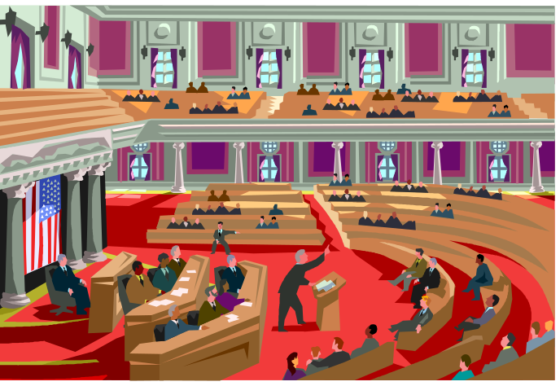


Private Practice in Federal Courts

Attorneys don’t have “specialties” in the strict sense of the word, they “practice in an area of the law” such as the ones listed here.

As an attorney in private practice in the federal courts, you’d have to be admitted into the state and federal Bar Associations of the district in which you reside and work.

You could work in may areas of the law, and represent clients all the way to the U.S. Supreme Court.


Family, Divorce & Elder Law
Criminal Law
Litigation
Native American Law
Real Estate & Construction
Health Law
Asian Law
Entertainment Law Employment & Workplace Law
General Practice
Accidents & Injuries
Wills Trusts & Estates
Business Law
Consumer & Automobile
Corporate Law
Sports Law
Animal Law
Intellectual Property Law

☺ An Attorney Practicing in Federal Courts
Walter R. Echo-Hawk, Jr.
Staff Attorney, Native American Rights Fund, Boulder, CO
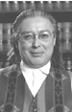

Walter R. Echo-Hawk, Jr. is a senior staff attorney in the Boulder office of the NARF, admitted to practice law before the United States Supreme Court, Colorado Supreme Court, U.S. Courts of Appeals for the Eighth, Ninth, and Tenth Circuits, and a host of federal District Courts. A lawyer, tribal judge, scholar and activist, his legal experience includes cases involving Native American religious freedom, prisoner rights, water rights, treaty rights, and reburial/repatriation rights.

In 1989, he negotiated a national reburial agreement with the Smithsonian Institution which was enacted into law. In 1989-90, he helped lead a national campaign for passage of the Native American Grave Protection and Repatriation Act - an important human rights law. In 1994, he represented the Native American Church of North America to secure passage of the American Indian Religious Freedom Act Amendments of 1994 to protect religious use of peyote by Indians. Presently he represents the Klamath Tribes of Oregon to quantify treaty-protected water rights in Southern Oregon in a highly publicized and controversial set of federal and state litigation.

A prolific writer, his publications include an award-winning book Battlefields and Burial Grounds (1994). He has received various awards, such as, the American Bar Association "Spirit of Excellence Award" for legal work in the face of adversity and the "Civil Liberties Award" from the ACLU of Oregon for significant contributions in the cause of individual freedom. Since 1995, Walter has served as a member of the Carter Center's International Human Rights Council.

Private Practice in State Courts
As an attorney in private practice in the state courts, you’d have to be admitted into the state Bar Associations of the district in which you reside and work.

Remember, attorneys don’t have “specialties” in the strict sense of the word, they “practice in an area of the law” such as:

Pretty much what you’d do in private practice at the federal level, but at the state level, in any state or U.S. territory!






Outer Space Law
http://www.oosa.unvienna.org/

United Nations Office for Outer Space Affairs (UN-OOSA)



The United Nations Office for Outer Space Affairs is the Secretariat for the Legal Subcommittee of the United Nations Committee on the Peaceful Uses of Outer Space (COPUOS), which is the primary international forum for the development of laws and principles governing outer space. In addition to providing parliamentary services, the Office prepares legal studies and background documents on various aspects of space law to assist member States in their deliberations. In accordance with the Action Plan endorsed by the General Assembly in its resolution 55/122, the Office provides information and advice, upon request, to governments, non-governmental organizations and the general public on space law in order to promote understanding, acceptance and implementation of the international space law agreements concluded under United Nations auspices.
Hey! Keep it down in that galaxy! I’m trying to sleep here!

NOTE: The U.S. has a Tax Court, Veterans Court, Bankruptcy Court, Military Courts, etc., but it doesn’t have an outer space court. Maybe you’ll help start one!
☺ A Space Law Attorney

Jaqueline Serrao, JD, Associate Director
National Remote Sensing and Space Law Center
Executive Editor of the Journal of Space Law
University of Mississippi Law School


Jaqueline Serrao earned her B.A., University of California Los Angeles, her J.D. at Golden Gate University School of Law, and her LL.M. at McGill University in Canada. She is a Member of the State Bar of California and is a certified private pilot.
Serrao was an associate at the California law firm Chevalier, Allen & Lichman, LLP, where she counseled public and private entities, including airports and airlines, in aviation, environmental, land use, regulatory law, international law, commercial transaction law, and appellate level litigation. Prior to joining Chevalier, Allen & Lichman, LLP, Serrao was an International Aviation Operations Specialist at the Office of International Aviation, FAA, where she was responsible for creating and analyzing policies related to the FAA's international program, with particular emphasis on overflight fees, and the International Aviation Safety Assessment Program.
Before her term at the FAA, Serrao was an Assistant Professor of Aerospace Law at the University of North Dakota, Center for Aerospace Sciences, where she taught Aerospace Law, and Airline/Airport Economics and Management.

http://www.spacelaw.olemiss.edu/
Cloning Law

United Nations Committee on an International Convention against the Reproductive Cloning of Human Beings

The U.N. General Assembly, in resolution 56/93 of 12 December 2001, decided to establish an Ad Hoc Committee, open to all States Members of the United Nations or members of specialized agencies or of the International Atomic Energy Agency, for the purpose of considering the elaboration of an international convention against the reproductive cloning of human beings.


http://www.un.org/law/cloning/
Hey, we look like that Irish dance group, Feet of Flame!
Intellectual Property

iRobot Files Patent and Copyright Infringement Lawsuit to Protect Roomba Robotic Floorvac

Industry Shorts - Nexus:
Monday, May 16, 2005 - 06:57 AM


BURLINGTON, Mass., May 9, 2005- iRobot Corp., today announced that the company has filed a lawsuit against Urus Industrial Corp. of Ontario, Canada, and Koolatron, a division of Urus Industrial Corp. Koolatron was a distributor of iRobot's Roomba(R) Robotic Floorvac for 15 months from March 2003 until May of last year, and began selling a "knock-off" version of the original Roomba in March of this year. iRobot is seeking damages and a permanent injunction to prevent the defendants from making, using, selling and offering for sale their Koolvac KV-1 vacuums and the packaging and manuals that accompany them. The lawsuit, filed in the U.S. District Court in Massachusetts, says Koolatron infringes on iRobot's patent, copyright and trade dress rights.

http://www.roboticstrends.com/

☺ An Intellectual Property Law Attorney


Arti K. Rai, JD
Professor of Law

Duke University School of Law

Arti K. Rai is an expert in patent law, the biopharmaceutical industry, and health care regulation. Her recent publications include "Open and Collaborative Research: A New Model for Biomedicine," in Intellectual Property Rights in Frontier Industries: Biotech and Software (AEI-Brookings Press, 2005); "Finding Cures for Tropical Diseases: Is Open Source an Answer?" Public Library of Science: Medicine (2004) (with Stephen M. Maurer and Andrej Sali); "Collective Action and Proprietary Rights: The Case of Biotechnology Research with Low Commercial Value," in International Public Goods and Transfer of Technology under a Globalized Intellectual Property Regime (Cambridge Univ. Press, 2005); and “Engaging Facts and Policy: A Multi-Institutional Approach to Patent System Reform,” 106 Columbia Law Review (2003).

Professor Rai joined the Duke Law faculty in 2003. In the fall of 2004, Rai was a Visiting Professor at Yale Law School. Prior to joining Duke, she was on the faculty of the University of Pennsylvania Law School, where she was also a visiting professor in Fall 2000. From 1997-2001, she was a faculty member at the University of San Diego School of Law. She has also been a faculty fellow in the Program in Ethics and the Professions at Harvard University; a MacLean fellow at the University of Chicago Center for Clinical Medical Ethics; and a trial attorney focused on health law at the United States Department of Justice, Civil Division, Federal Programs Branch. She was an associate at the firm of Jenner & Block, in Washington D.C., after completing a clerkship with Judge Marilyn Hall Patel on the United States District Court for the Northern District of California in San Francisco.

Animal Law & Animal Protection Issues


Gary L. Francione
Professor of Animal Law, Rutgers University



Professor Francione has written extensively on animals and the law, including Animals, Property, and the Law (1995) Introduction to Animal Rights: Your Child or the Dog? (2000), Vivisection and Dissection in the Classroom: A Guide to Conscientious Objection (1992). For ten years, Professor Francione and Adjunct Professor Anna Charlton operated a litigation clinic that focused on animal protection issues. Professor Francione has edited a book series, America in Transition: Radical Perspectives for Temple University Press, and he has produced and hosted various programs on political and environmental topics at WBAI, 99.5 FM/NYC.

http://www.animal-law.org/
http://www.lclark.edu/org/animalaw/
Indian Law & Tribal Courts

Gloria Valencia-Weber
Professor of Law, founder of Indian Law Programs

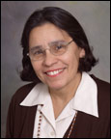
Gloria Valencia-Weber received a bachelors and masters degree from Oklahoma State University, and a J.D.from Harvard University.
In 1994 at the UNM law school she established the Indian Law Certificate Program, which is now one of the top Indian Law program’s in the country.
Valencia-Weber, a bilingual child of Mexican Indian heritage, and her career includes working for the American Civil Liberties Union, coordinating a diversified students program and teaching psychology at Oklahoma State University. She is self-taught in Indian Law since these offerings were scarce up until recently. In addition to the program at UNM Law, she established the Indian Law certificate program at the University of Tulsa College of Law.

http://lawschool.unm.edu/indian/
http://www.law.utulsa.edu/indianlaw/

Computer Crime Law



The Computer Crime and Intellectual Property Section (CCIPS) of the U.S. Department of Justice is responsible for implementing the Department's national strategies in combating computer and intellectual property crimes worldwide. The CCIPS prevents, investigates, and prosecutes computer crimes by working with other government agencies, the private sector, academic institutions, and foreign counterparts. Attorneys work to improve the domestic and international infrastructure-legal, technological, and operational-to pursue network criminals most effectively. The Section's enforcement responsibilities against intellectual property crimes are similarly multi-faceted. Intellectual Property (IP) has become one of the principal U.S. economic engines, and the nation is a target of choice for thieves of material protected by copyright, trademark, or trade-secret designation. In pursuing all these goals, CCIPS attorneys regularly run complex investigations, resolve unique legal and investigative issues raised by emerging computer and telecommunications technologies; litigate cases; provide litigation support to other prosecutors; train federal, state, and local law enforcement personnel; comment on and propose legislation; and initiate and participate in international efforts to combat cybercrime.


Law School Administration

Elena Kagan
Dean Harvard Law School

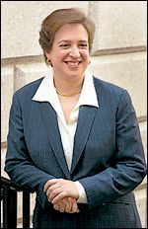
Two years after the US Senate let Elena Kagan's nomination to a federal circuit court lapse, the law school has selected her as its first female dean. Few are more pleasantly surprised by the appointment than the handful of women who graduated in the first class that accepted women exactly 50 years ago.
"It sends a real message," says Charlotte Armstrong, who was among the first batch of women to attend the school.
During their orientation in 1953, Harvard Law's dean asked why the women bothered showing up. More than a decade later, certain professors would only recognize women students on Ladies' Day, recalls Mary Mullarkey, who went on to serve as chief justice of the Colorado Supreme Court after graduating from Harvard Law in 1968.

Yet Ms. Armstrong says that Ms. Kagan's gender is far from her best qualification. "She's brilliant, she's energetic, she's focused, and she's passionate about the law school," Armstrong says.

http://www.law.harvard.edu/

Employment Law


Employment law is a broad area encompassing all areas of the employer/employee relationship except the negotiation process covered by labor law and collective bargaining. Employment law consists of thousands of Federal and state statutes, administrative regulations, and judicial decisions. Many employment laws (e.g., minimum wage regulations, employment discrimination, sexual harassment) were enacted as protective labor legislation. Other employment laws take the form of public insurance, such as unemployment compensation.

Labor Law


The goal of federal and state labor laws is to equalize the bargaining power between employers and employees. The laws primarily deal with the relationship between employers and unions. Labor laws grant employees the right to unionize, and allows employers and employees to engage in certain activities (e.g. strikes, picketing, seeking injunctions, lockouts) so as to have their demands fulfilled.

Public Office

Beth Kerttula
Representative, Alaska House of Representatives


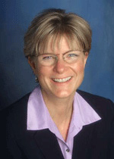
Alaskan Beth Kertulla was elected to the Alaska House of Representatives in 1998, 2000, 2002, and 2004. She has served on the House Committees on Resources, Oil and Gas, Budget and Audit, Finance, Fisheries, Economic Development and Tourism. She is a former Assistant Attorney General and legal counsel for the Alaska State Senate Judiciary Committee. She graduated from Stanford University with a BA Political Science and University of Santa Clara School of Law in 1981.

Environmental Law

Environmental Law Alliance Worldwide (E-Law)

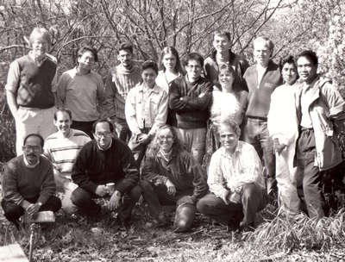
Public interest lawyers from 10 countries founded E-LAW in 1989. These lawyers were working together at a public interest law conference at the University of Oregon School of Law. As they talked, they discovered that communities in their countries were facing similar environmental challenges. They realized that if they could share strategies and legal and scientific information across borders, they could promote environmental protection more effectively.

E-LAW's founders agreed to collaborate, replicate successful environmental policies and learn from each other's experience. They began their cross-border collaboration in the early days of e-mail.
As the network of public interest lawyers grew, E-LAW became a pioneer in wiring the grassroots. E-LAW brought the first e-mail service to public interest advocates in Indonesia and Mongolia.
Today, more than 300 public interest advocates from 60 countries participate in the E-LAW network

Early members of the E-LAW network in March, 1992
http://www.elaw.org/
Advocacy for Children’s Rights

Marian Wright Edelman
Advocate, author, founder of Children’s Defense Fund

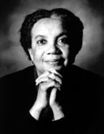
Marian Wright Edelman, founder and president of the Children's Defense Fund (CDF), has been an advocate for disadvantaged Americans for her entire professional career. Under her leadership, the mission of the Children's Defense Fund is to Leave No Child Behind and to ensure every child a Healthy Start, a Head Start, a Fair Start, a Safe Start, and a Moral Start in life with the support of caring families and communities.
Mrs. Edelman, a graduate of Spellman College and Yale Law School, began her career in the mid-60s when, as the first black woman admitted to the Mississippi Bar, she directed the NAACP Legal Defense and Educational Fund office in Jackson, Mississippi. In l968, she moved to Washington, D.C. as counsel for the Poor People's March that Dr. Martin Luther King, Jr. began organizing before his death. She founded the Washington Research Project, which was the parent body of the Children's Defense Fund. For two years she served as the Director of the Center for Law and Education at Harvard University and in 1973 began CDF.

http://www.childrensdefense.org/

Advocacy for Victim’s Rights

Katherine J. Hansen
Attorney for Victims’ Rights, Alaska Office of Victims’ Rights

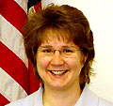
Katherine J. Hansen has been practicing law in Alaska since 1989 as both an assistant district attorney and an assistant attorney general in Fairbanks, Bethel, Ft. Yukon, Delta, Tok, and Anchorage.
Her work as a criminal prosecutor has taken her to numerous rural Native Alaska villages where she gained specialized knowledge of the Department of Law and the Alaska Court System’s procedures for handling criminal matters including the state’s Victims’ Rights Act. As a former assistant attorney general handling Child In Need Of Aid cases she gained important experience working with families in crisis and with tribal governments involving highly personal and sensitive family issues.
Ms. Hansen arrived in Anchorage with her family when she was 5 and grew up in Fairbanks where she graduated from high school. She graduated from the University of Alaska Fairbanks in 1993 with a Bachelor of Science degree and obtained her Juris Doctor law degree in 1997 from Suffolk University Law School in Boston where she graduated Cum Laude. She represents clients who reside in rural Alaska.

http://www.officeofvictimsrights.legis.state.ak.us/

Entertainment Law

This area of the law generally involves creating and negotiating those multi-million dollar contracts and engagements for the performers. It is a highly-competitive and fast-paced practice.




Tax Law



Tax law doesn’t have anything to do with filling out people’s tax forms for them. It is a very complex area that deals with U.S. Code Title 26 – The Internal Revenue Code, which some lawyers say is about as large as a school auditorium! A good tax lawyer works with his/her clients in advance to plan business and personal finances in order to ensure sound tax consequences. He/she also represents people in front of the IRS and in front of the U.S. Tax Court.

Tax Law includes estate and gift taxes, employment taxes, miscellaneous excise taxes, alcohol, tobacco, and certain other excise taxes, trust funds, coal industry health benefits and group health plan requirements. Small business owners are usually asking Congress to change the IRS Code in certain area, because business owners understand better than anyone, that any business decisions have tax consequences that can hurt their business.

Tax law also includes issues having to do with financing of a presidential election!

Political Advocacy

Rubén Blades
Politician and Salsa Pop Performer

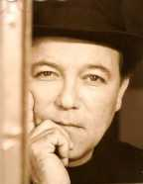
Singer, actor and political figure, Blades was born on 16 July 1948, in Panama City, Panama. His grandmother had a great influence on him.

"My abuela (grandma) Emma who was with me at all times, instilled me with a sense of justice, that we can all serve as part of the solution. That is the perspective from which I developed and the foundation to help me move forward."

During his adolescence, his family was relatively poor. In 1964, 21 civilians were killed and hundreds wounded in student riots, by U.S. soldiers, when students tried to fly the flag of Panama next to that of the U.S. at Balboa High School. This event was traumatic for the nation, and deeply influenced Blades. After this he continued his studies and eventually entered the law school at the University of Panama.

In 1968, the university closed due to riots, so he traveled to New York City where he began recording his music. Despite continuing political and economic problems in Panama, Blades returned to the country to finish his law degree when the university reopened. In 1998 he was a political candidate for president of Panama.

http://www.rubenblades.com/
Teaching the Law

Patricia J. Williams
Professor, columnist and author


Patricia J. Williams, a professor of law at Columbia University, was born in Boston in 1951 and holds a BA from Wellesley College and a JD from Harvard Law School. She was a fellow in the School of Criticism and Theory at Dartmouth College and has been an associate professor at the University of Wisconsin School Law School and its department of women's studies. Williams also worked as a consumer advocate in the office of the City Attorney in Los Angeles.
Her publications include Anthony Burns: The Defeat and Triumph of a Fugitive Slave, On Being the Object of Property, The Electronic Transformation of Law and And We Are Not Married: A Journal of Musings on Legal Language and the Ideology of Style.
In 1993, Harvard University Press published Williams's The Alchemy of Race & Rights to widespread critical acclaim. She is also author of The Rooster's Egg (Harvard, 1995), and, most recently, Seeing a Color-Blind Future: The Paradox of Race (Reith Lectures, 1997) (Noonday Press, 1998).

Writing & Making Movies about the Law




John Grisham
Lawyer and mystery writer!


John Grisham was born in Jonesboro, Arkansas, on February 8, 1955. He received a degree in accounting from Mississippi State University in 1977 earned a law degree in 1981 from the University of Mississippi. He established a law practice in Southaven, where he practiced both criminal and civil law.
In 1989 he published his first novel, A Time to Kill. The book received some good reviews but sold only moderately well. His next book, however, would be a different story. Completed in 1988, The Firm would be his break-out hit. In 1990, before the novel was published, Paramount Pictures purchased the film rights for $600,000. Since then, Grisham has gone on to be recognized as one of the world's bestselling novelists.

http://www.randomhouse.com/features/grisham/
Protecting the Consumer




Lemon Law

Every state, along with the District of Columbia, has a lemon law. Lemon laws establish a standard for when vehicles should be repurchased or replaced by the manufacturer. The lemon laws contain eligibility requirements, notice requirements, and also set out specific remedies that a consumer may recover in a legal action against the manufacturer if a vehicle cannot be fixed to conform to the warranty after a reasonable number of repair attempts. It is important for you to advice your clients on their rights and responsibilities.

Transportation Law
An area of the law that deals with safety and logistics of trucking, railroad, aviation, and all sorts of transportation.









NTSB SAYS PILOT'S EXCESSIVE RUDDER PEDAL INPUTS LED TO CRASH OF AMERICAN FLIGHT 587 October 26, 2004 NTSB-04-31

Washington, D.C. – On November 12, 2001 American Airlines flight 587 crashed into a Queens, NY, neighborhood because the plane's vertical stabilizer separated in flight as a result of aerodynamic loads that were created by the first officer's unnecessary and excessive rudder pedal inputs after the aircraft encountered wake turbulence, according to a final report adopted by the National Transportation Safety Board today. The Board said that contributing to the crash were characteristics of the airplane's rudder system design and elements of the airline's pilot training program.
The Safety Board said that, although other pilots provided generally positive comments about the first officer's abilities, two pilots noted incidents that showed that he had a tendency to overreact to wake turbulence encounters. His use of the rudder was not an appropriate response to the turbulence, which in itself provided no danger to the stability of the aircraft, the Board found.
The Board concluded that, before the crash of flight 587, pilots were not being adequately trained on what effect rudder pedal inputs have on the Airbus A300- 600 at high airspeeds, and how the airplane's rudder travel limiter system operates.

Aviation Law


Aviation law governs the operation of aircraft and the maintenance of aviation facilities. Both federal and state governments have enacted statutes and created administrative agencies to regulate air traffic.


Using its constitutional authority to regulate interstate and foreign commerce, Congress may enact laws pertaining to air navigation.

Then Federal Aviation Act was passed in 1958 establishing the Federal Aviation Agency. There have been several subsequent acts passed by the federal government regulating aviation such as the Airport and Airway Development Act of 1970 and the Airline Deregulation Act of 1978.

In the wake of the September 11, 2001 terrorist attacks, Congress enacted the Aviation and Transportation Security Act of 2001, which established a Transportation Security Administration (TSA) in the Department of Transportation. The TSA now resides in the Department of Homeland Security.

Admiralty Law


Admiralty law or maritime law governs navigation and shipping. It is a highly complex area of the law since it often deals with issues that may occur in international waters or with ships that dock in U.S. ports but are registered in other countries. A large portion of admiralty law comes from the European legal system that was in place when Columbus landed on the western hemisphere. This field may include: shipping; navigation; waters; commerce; seamen; towage; wharves, piers, and docks; insurance; maritime liens; canals; and recreation. Piracy (ship hijacking) is also an aspect of admiralty.



Homeland Security

The Department of Homeland Security is the most comprehensive reorganization of the Federal government in a half-century, consolidating 22 agencies and 180,000 employees into a single agency dedicated to protecting America from terrorism.

There are many legal issues associated with the DHLS and the Patriot Act which allows the department and the law enforcement agencies to perform in a manner conducive to deterring or stopping terrorist attacks on U.S. soil. In the years to come both the department and the Act will be the subject of much legal debate in this country.
Name this Act…

This Act may be cited as the “Uniting and Strengthening America by Providing Appropriate Tools Required to Intercept and Obstruct Terrorism”

Financial Crimes Enforcement






The Financial Crimes Enforcement Network (FinCEN) is a network, a means of bringing people and information together to fight the complex problem of money laundering. Since its creation in 1990, FinCEN has worked to maximize information sharing among law enforcement agencies and its other partners in the regulatory and financial communities. Working together is critical in succeeding against today's criminals. No organization, no agency, no financial institution can do it alone. Through cooperation and partnerships, FinCEN's network approach encourages cost-effective and efficient measures to combat money laundering domestically and internationally.

Sports Law


Sports Law encompasses a multitude of areas of law brought together in unique ways. Issues such as antitrust, contracts, and torts are quite common. Sports Law can be roughly divided into the areas of amateur, professional, and international sports. The distinction between a professional and amateur athlete is somewhat tenuous. So-called "amateur" student/athletes at universities often receive scholarships and other forms of compensation. Also, keep in mind that even though an athlete may be defined as an amateur by one organization, he or she may not be an amateur according to another. Of course, this leads to even more confusion. A simplistic, yet useful definition is that amateur athletes participate in sports as an avocation while professional athletes are involved in sports as a vocation.







Does any profession appeal more strongly than that of the law? The minister speaks for the life beyond. The doctor cares for our bodies. But the lawyer takes social and business men as they are, and strives to adjust their actions to the present well-being of all.

-David J. Brewer

The Bench
The Bar

Consider a career on the Bench or in the Bar. And remember…the same number of years will pass you by, whether or not you are studying and preparing for a career, or are just letting things happen to you.

We ask ourselves: “who am I to be brilliant, gorgeous, talented and fabulous”? Actually, who are you not to be?
—Nelson Mandela, 1994
Johannesburg, South Africa

