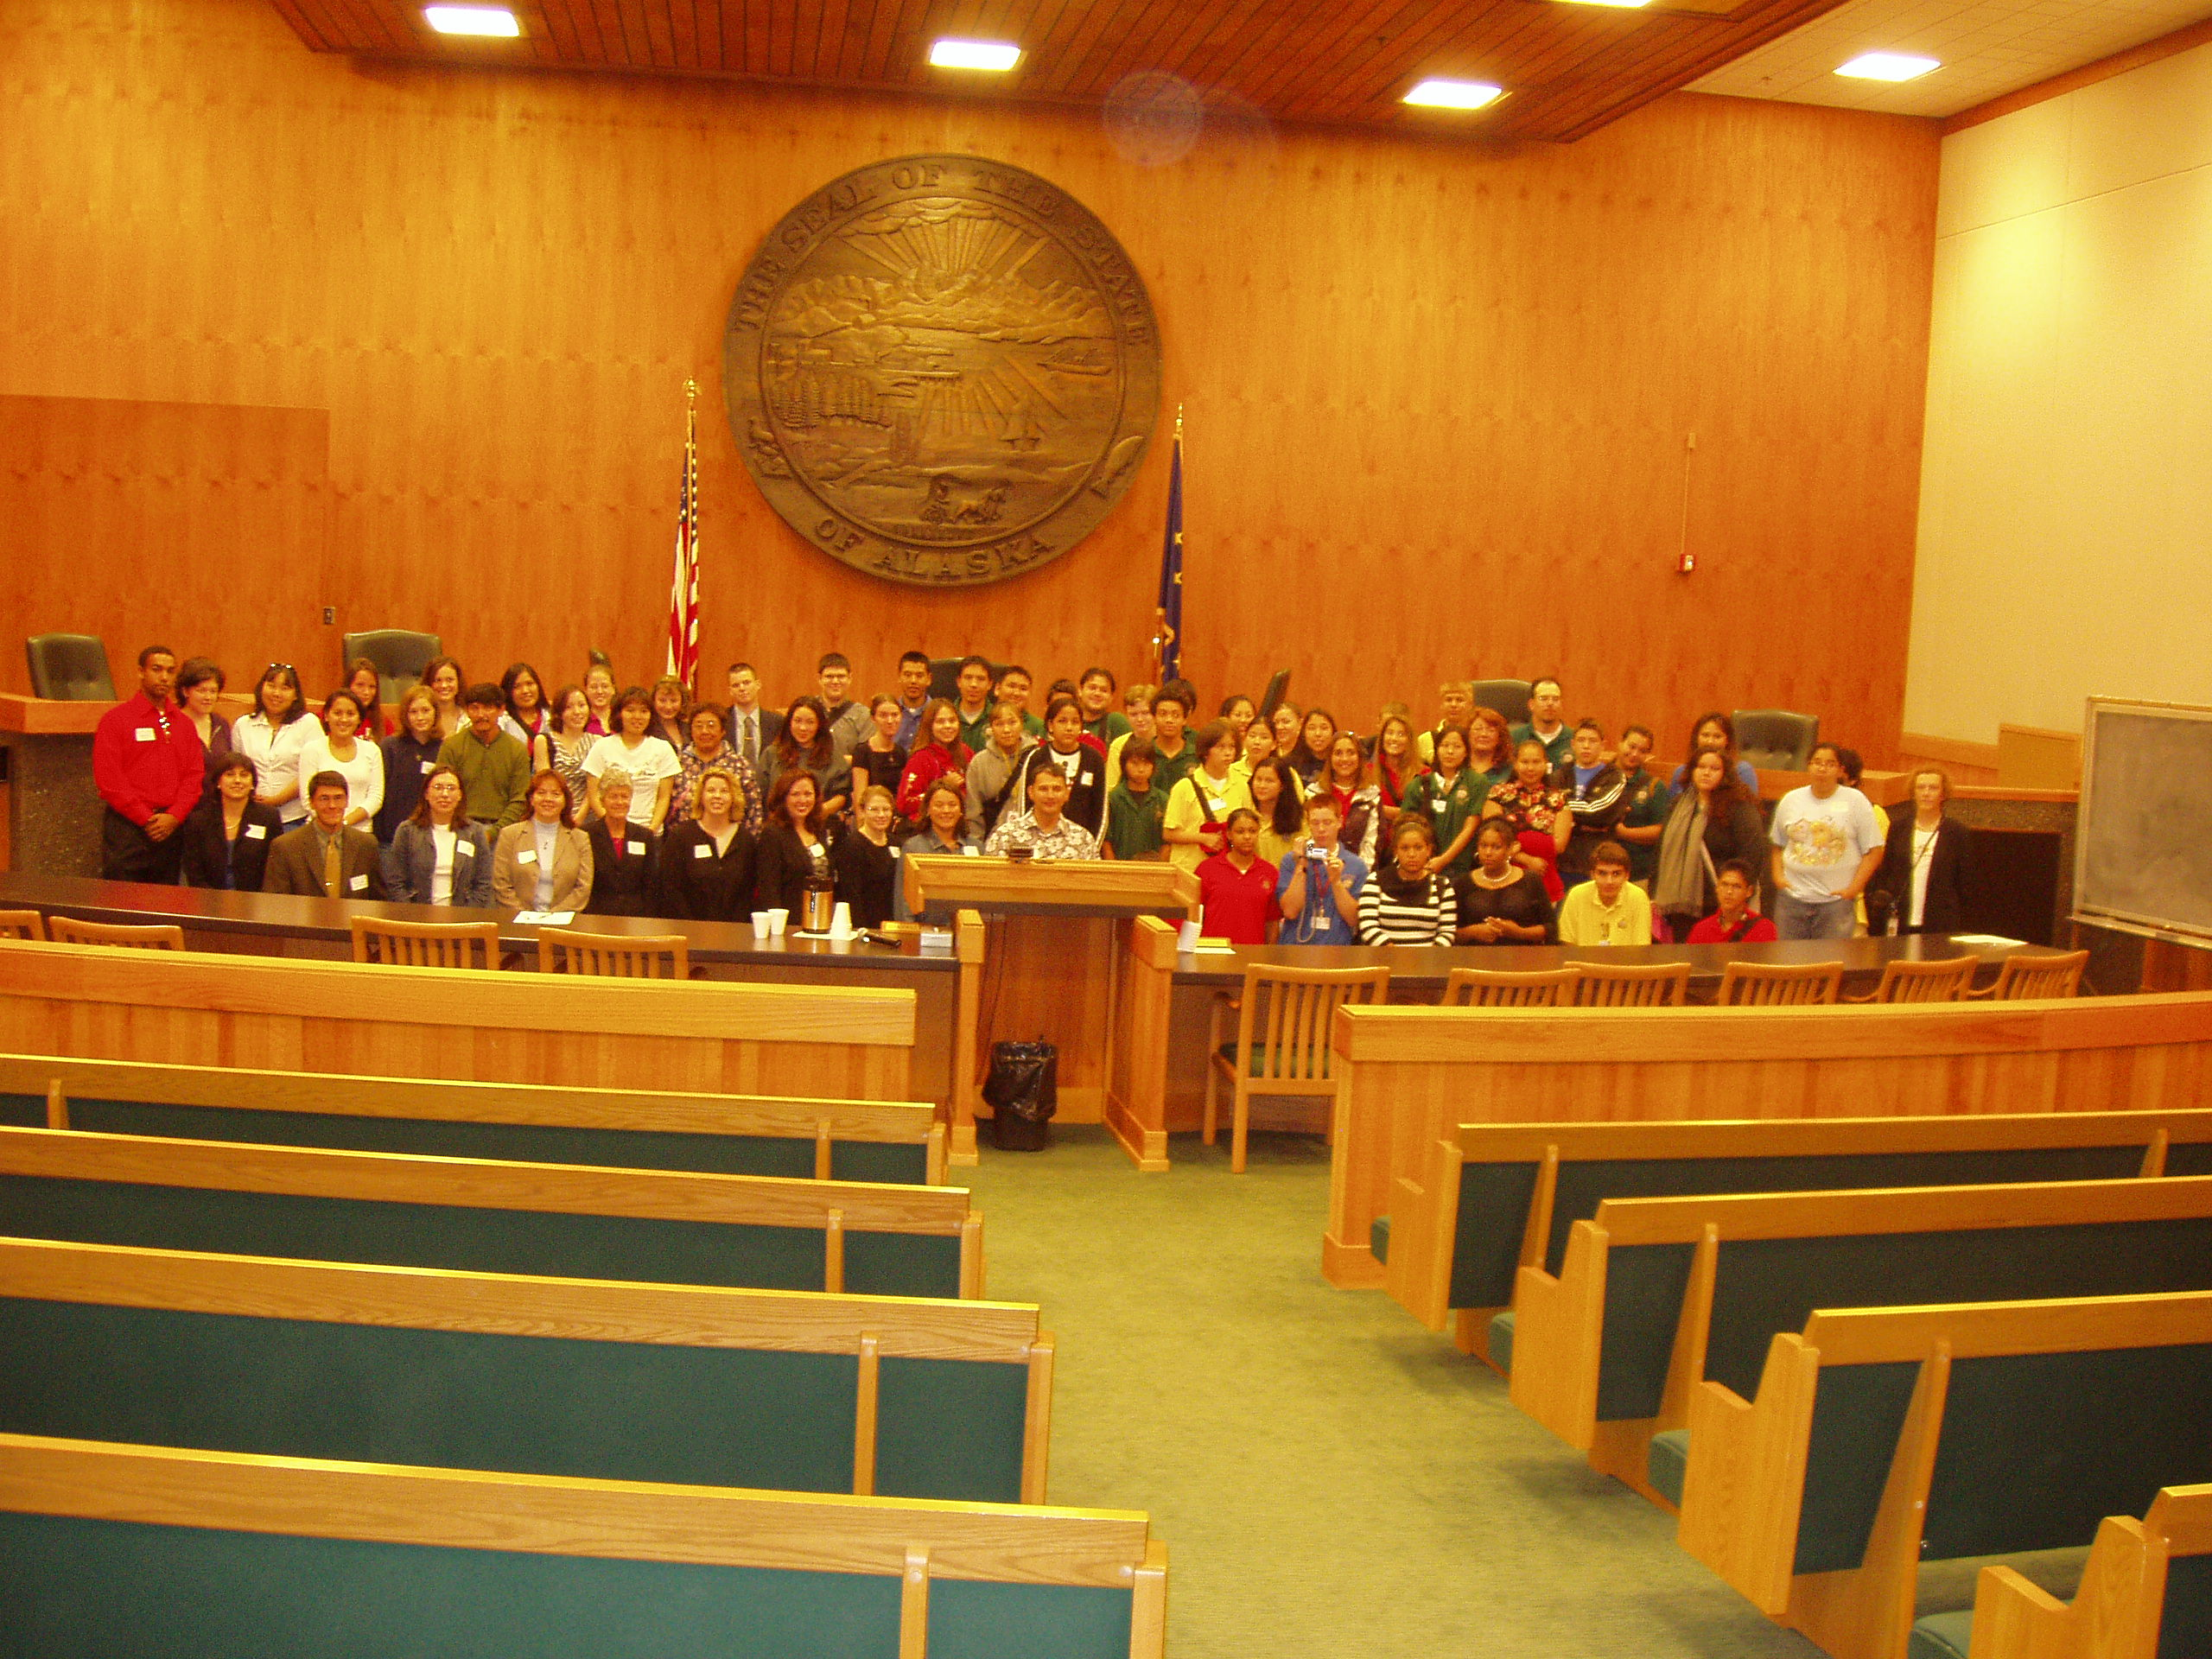
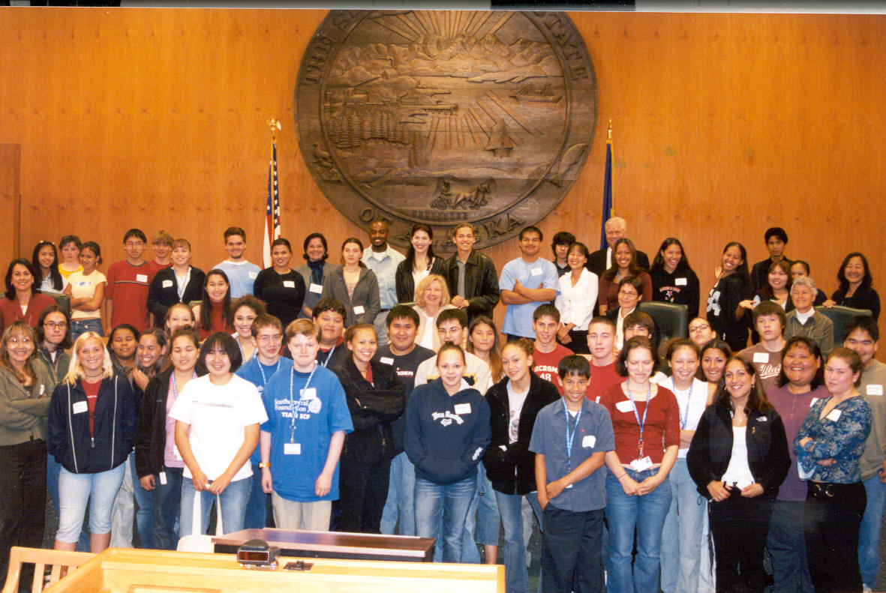
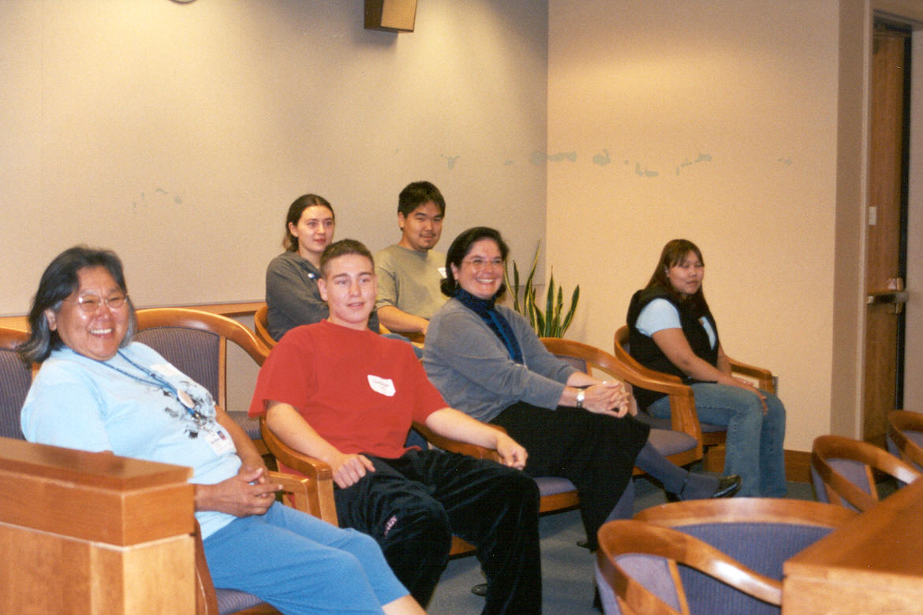
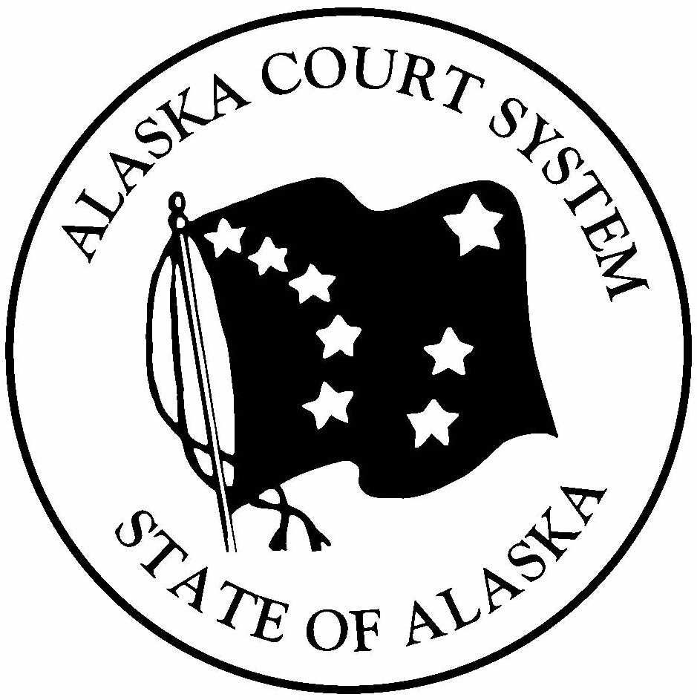







Color of Justice
Friday, April 29, 2005
Alaska Supreme Court courtroom
8:00 a.m. to 4:30 p.m.
5th Floor, Boney Courthouse, 303 K Street
Anchorage, Alaska
A fun, one-day program of lectures, presentations, skits and mock trials to encourage high school minority students, ages 15—18, to pursue careers as lawyers and judges! Students meet lawyers, judges and law school professors, they participate in mock trials and skits about the law and the judiciary, and enjoy a complimentary breakfast and lunch, courtesy of the Alaska Native Justice Center!

Registration is FREE! Enroll today!
A limited number of $300 travel scholarships are available.
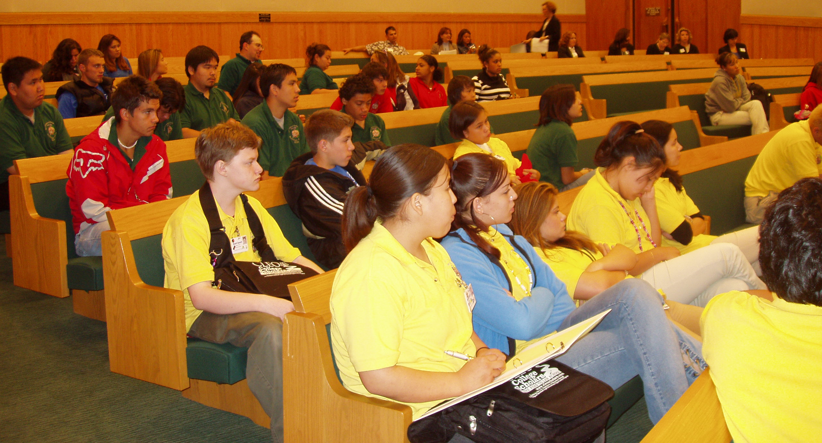
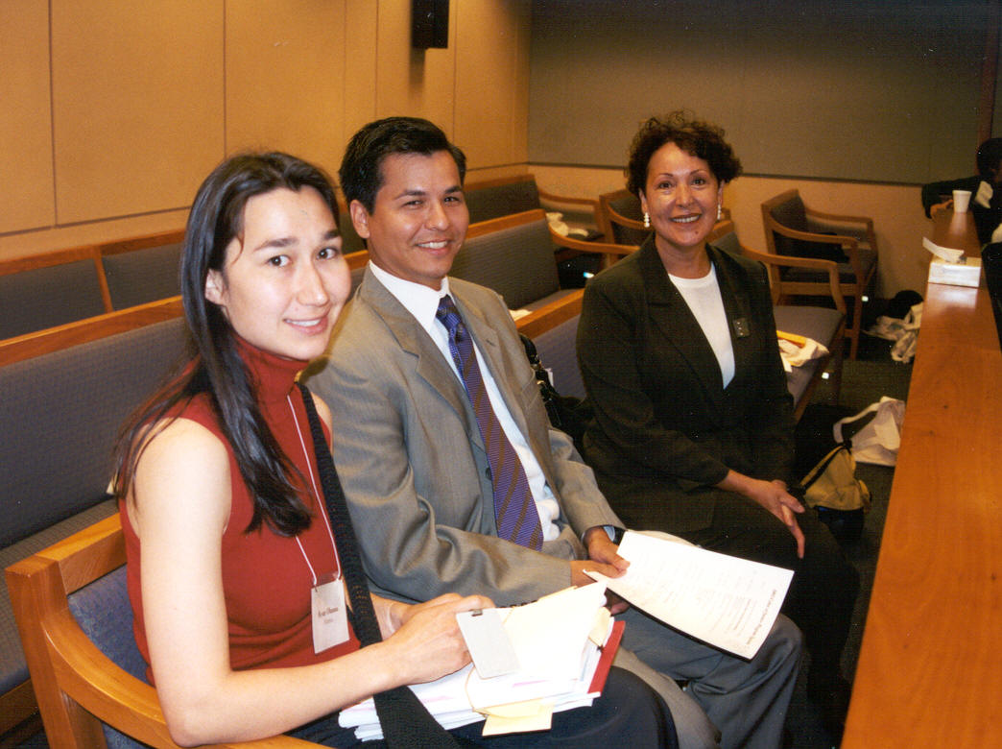
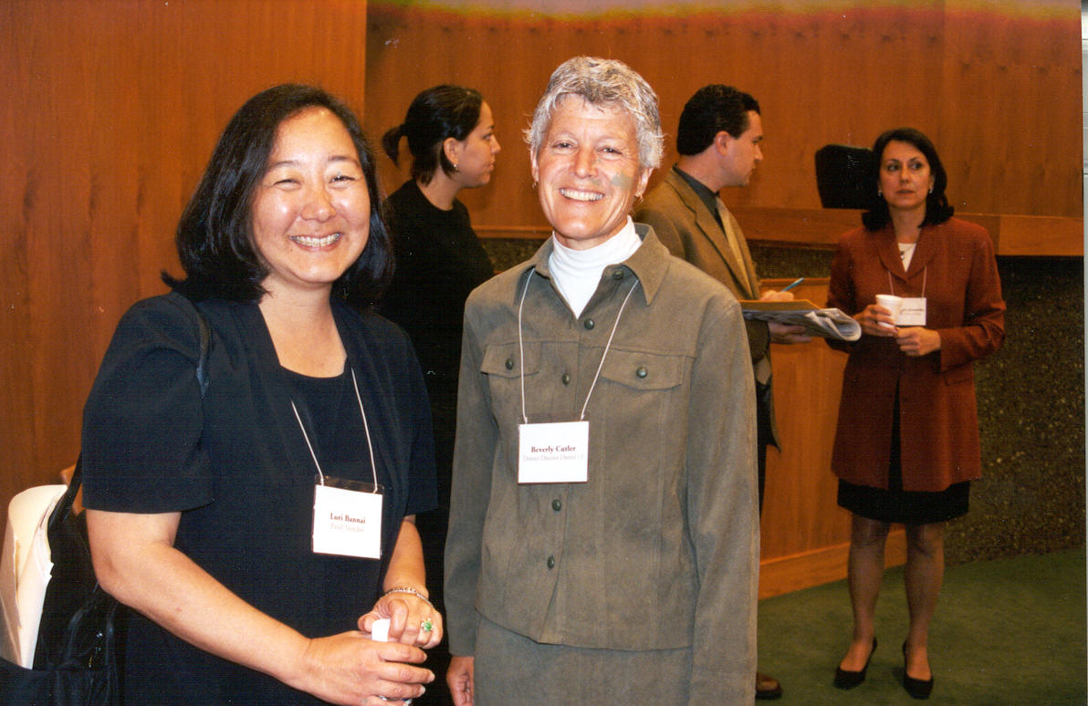
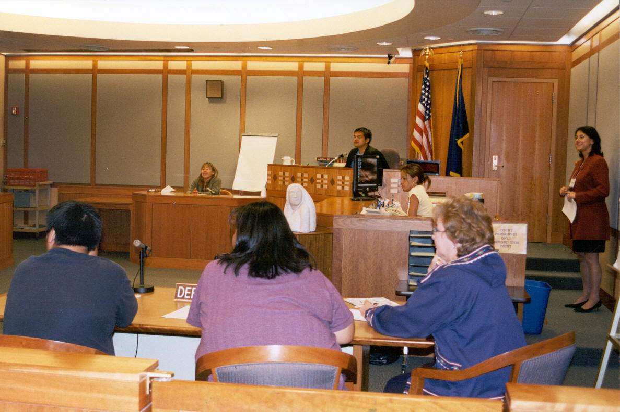
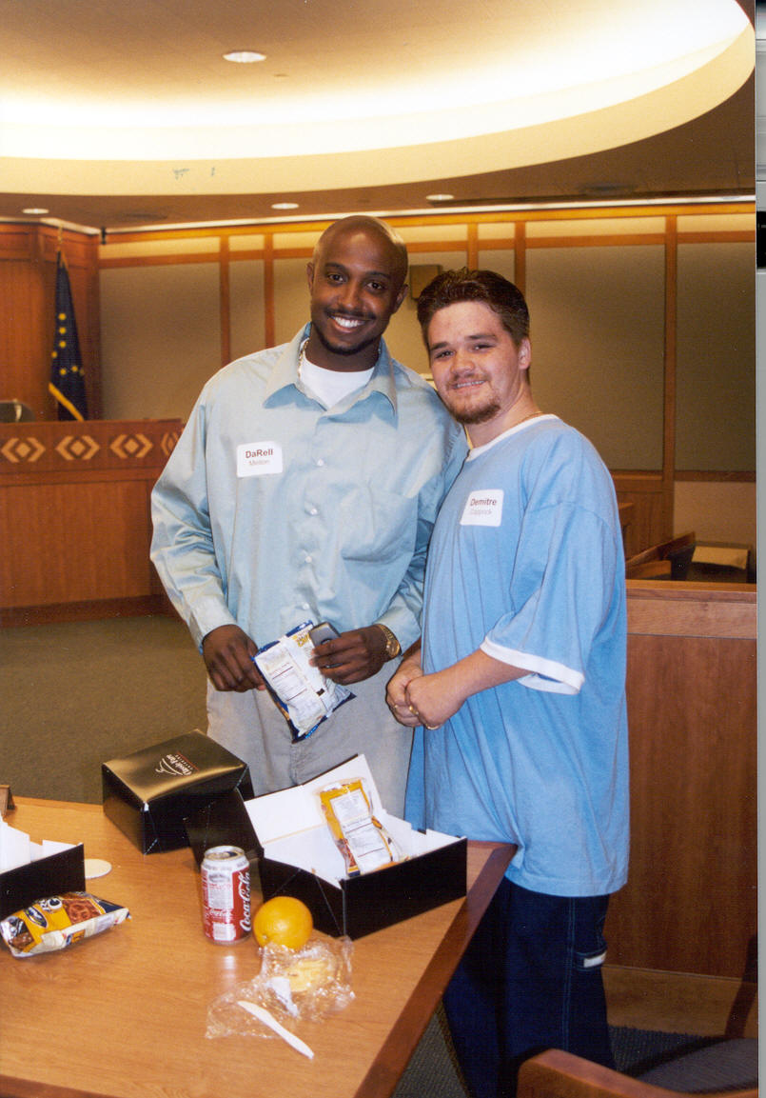
The National Association of Women Judges
The Alaska Court System
The Alaska Native Justice Center
Seattle University School of Law
University of Washington School of Law
Gonzaga University School of Law
University of Alaska Anchorage
invite you to attend this fun event!

The Color of Justice 2005 is a one-day event to encourage you to consider a career as a lawyer and judge. The program brings you in contact with practicing judges and lawyers who share their experiences, and answer your questions about what it takes, and what it is like to be in these professions. You can expect to participate, debate and observe the legal process in action through skits, mock trials and exercises designed to give you the “big picture”. Continental breakfast, lunch and snacks will be served, courtesy of the Alaska Native Justice Center.

This is the third year for this program, and each year we’ve had approximately 65 students from all points in Alaska, who like yourself, may soon become a lawyer or judge in Alaska’s legal process. So plan to come this year. Register today, and send your signed enrollment form to us by no later than Wednesday, April 27!

TRAVEL SCHOLARSHIPS
We have a limited number of $300 travel scholarships. To be considered for one, you need to submit this enrollment form, and a one-page, double-spaced essay, on “Why I am Interested in The Field of Law”. Your completed, signed enrollment form and essay must be received by us by no later than 5:00 p.m., Friday, April 8.

Please, also explore other funding sources for travel expenses such as your regional or local corporation and non-profit association’s education departments. Check the ANCSA Education Consortium List that assists Corporation shareholders and members in locating funding assistance.

For information
The Color of Justice 2005 Enrollment Form

STUDENT INFORMATION:

Student Name: Date of Birth
Address:
Home Phone Cell Phone

PARENT OR GUARDIAN INFORMATION:

Name:
Relationship:
Address:

Home Phone Cell Phone

PARENTAL DECLARATIONS:

- PARTICIPATION - I hereby give consent for my child to attend and participate in the program The Color of Justice 2005, to be held Friday, April 29, 2005, in the Boney Courthouse, 303 K Street; in various courtrooms in the Nesbett Courthouse at 825 W. 4th Avenue, and in the Training Room in the Snowden Building at 820 W. 4th Avenue, Anchorage, Alaska. I understand that the event organizers assume no responsibility for the travel and transportation of my student to and from this event. I further acknowledge that I have made arrangements for the supervision of my child to and from this event.

- USE OF PHOTO & NAME - I hereby give consent for my child’s name and image to be included in any publication or broadcast specifically about the Color of Justice 2005.

Parent or Guardian Signature Date Signed

NOTE: Unsigned forms will not be accepted.

Mail, hand-deliver, or fax this completed and signed form to:

 I WOULD LIKE TO BE CONSIDERED FOR A TRAVEL SCHOLARSHIP, AND I UNDERSTAND THAT WITH THIS COMPLETED FORM I HAVE TO SUBMIT AN ESSAY ON “Why I am Interested in The Field of Law”. I UNDERSTAND THAT THIS FORM AND ESSAY MUST BE RECEIVED IN ANCHORAGE BY NO LATER THAN 5:00 P.M., FRIDAY, APRIL 8.

