Midwestern Leadership Conference
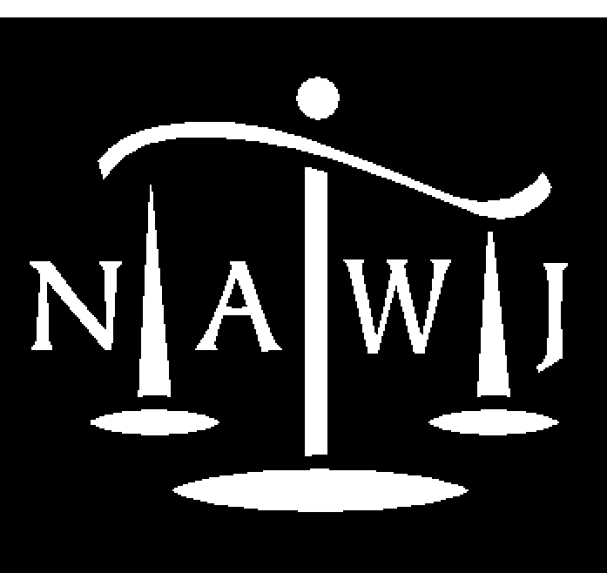
National Association of Women Judges
August 27-29, 2008
InterContinental Chicago, IL

Silver Sponsorship Levels and Benefits

Silver ($2,500): Entitled to:
Four tickets to 8/ 28 Justice Ginsburg Luncheon
Four tickets to 8/28 Morning Plenary Session
Four tickets to 8/28 Afternoon Scott Turow presentation
Four tickets to 8/28 Afternoon Women Law Firm Attrition/Judicial Diversity panel
Four tickets to 8/28 Closing Judicial Reception

Recognition as Conference Silver Sponsor via:
- Quarter-page ad in Conference Program
- Recognition during Conference events, via posters and video loops
- Listing in the formal Invitation sent to 3,000 women judges in the Midwest, together with NAWJ Board of Directors and full membership
- Listing in all press releases and other pre-Conference publicity untended for the general public
- Listing in all NAWJ publications sent to all members, including e-mailed Monthly Update, semi-annual publication (Counterbalance), semi-annual Board Reports, and 2008 Annual Report and in informal updates to Chicago Judges’ Planning Committee.

