Midwestern Leadership Conference
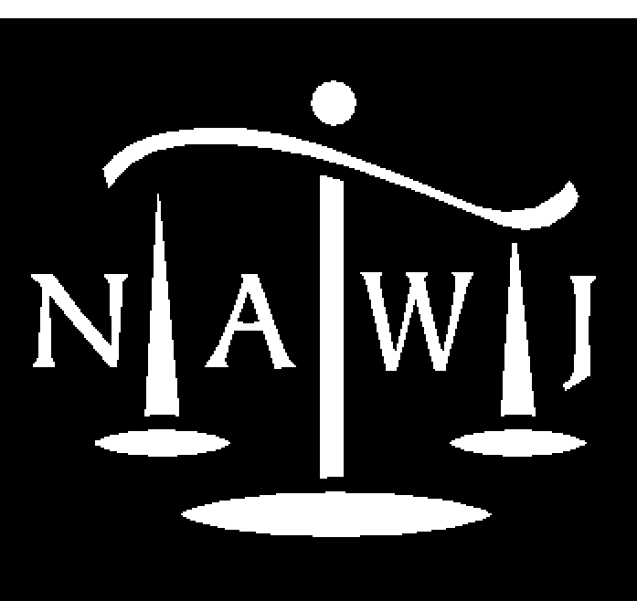
National Association of Women Judges
August 27-29, 2008
InterContinental Chicago, IL

Gold Sponsorship Levels and Benefits

Gold ($5,000): Entitled to:
Eight tickets to the 8/28 Justice Ginsburg Luncheon (at the Sponsor’s option, all 8 tickets may be used for the Sponsor and Sponsor’s guests, or a Judge will be seated at the Sponsor’s table and seven tickets will be available to the Sponsor and the Sponsor’s guests and up to two non-Sponsor guests will be seated at the table, or four tickets will be situated at each of two tables, with a Judge and up to five non-Sponsor guests seated at each table) plus
Eight tickets to 8/28 Morning Plenary Session
Eight tickets to 8/28 Afternoon Scott Turow presentation
Eight tickets to 8/28 Afternoon Women Law Firm Attrition/Judicial Diversity panel
Eight tickets to 8/28 Closing Judicial Reception

Recognition as Conference Gold Sponsor via:
- Half-page ad in Conference Program
- Listing in the formal Invitation sent to 3,000 women judges in the Midwest, together with NAWJ Board of Directors and full membership
- Listing in all press releases and other pre-Conference publicity untended for the general public
- Listing in all NAWJ publications sent to all members, including e-mailed Monthly Update, semi-annual publication (Counterbalance), semi-annual Board Reports, and 2008 Annual
- Report and in informal updates to Chicago Judges’ Planning Committee.

